



CLASS XII

RECORD OF PROJECT WORK IN

COMPUTER SCIENCE

Name : -------------------------------------------------------

Roll No : -----------------------------------------------------



Project Report submitted in fulfillment of Class XII

Syllabus Requirement By

--------------------------------------------------------------------

CERTIFICATE

This is to certify that this Project titled -----------------------------------------------------

----------------------------------------------------------------------------------------------------

is the record of bonafide project work carried out by ------------------------------------

----------------------------------------------------Roll .No. -------------------------of class XII, in the laboratory of this school during the academic year 2019 – 2020

Teacher in Charge Principal Examiner

COMPUTER SCIENCE

PROJECT



CONTENTS

Page No

-Acknowledgement 5

-Project Overview 6

- Functions Used 7

-Source Code 8

-Screenshots 32

-Bibliography 59

Acknowledgement

Firstly I thank God almighty for all the blessings that

he showered upon me and my teammates in the

course of this project.

I would like to thank my computer teachers

***Mr. Cherian Abraham*** and ***Mrs. Thanuja Mathew*** for

their help and guidance throughout the completion

of this project.

I also express my sincere gratitude to the Principal

***Fr. Sunny Kuruvilla*** and the Vice Principal

***Fr. Manu K Mathew*** for allowing my team to

undertake this project and for providing all

necessary facilities.

I’m deeply thankful to my parents and my friends for

their constant support and motivation.

Most of all, I thank my teammates for their tireless

effort without which this project couldn’t have been

completed successfully.

PROJECT OVERVIEW

The C++ programming language was developed at

***AT&T Bell Laboratories*** in the early 1980’s by

***Bjarne Stroustrup***.

He found ‘C’ lacking for stimulations and decided to

extend the language by adding features from his

favorite language ***Stimula 67.***

This project in C++

***“AIMBOT GAMING”***

uses C++ features like files, classes, functions etc.

This program is intended to manage a gaming centre

FUNCTIONS USED

mfiles() : to enter member's data into the file

gfiles() : to enter guest's data into the file

mstatus() : to access members's status from the file

gstatus() : to access guest's status from the file

addmember() : to add a new member

list() : to display the list of members

m_remove() : to remove a member

SOURCE CODE

#include<fstream.h>

#include<string.h>

#include<stdio.h>

#include<dos.h>

#include<conio.h>

int flag = 0;

class aimbot

{

int mch1, mch2, gch1, gch2, mttime, gttime, m_id, id, check, f;

float mprice, gprice;

char mname[50], gname[50], mgame[24], ggame[24], mpackage[30];

char , gpackage[30], usr_id[50];

public:

void menter(); //allows members to enter the required data

void mprint(); //to print member's bill

void mfiles(); //to enter member's data into the file

void genter(); //allows guest to enter the required data

void gprint(); //to print guest's bill

void gfiles(); //to enter guest's data into the file

void mstatus(); //to access members's status from the file

void msprint(); //to display member's status

void gstatus(); //to access guest's status from the file

void gsprint(); //to display guest's status

void addmember(); //to add a new member

void list(); //to display the list of members

int compare(int i_d); /*to check whether the id entered by the member is

already registered*/

void m_remove(); //to remove a member

} m, g;

void aimbot::m_remove()

{

int i_d;

clrscr();

ifstream fio("list.dat", ios::in);

ofstream file("temp.dat", ios::out | ios::app);

int rno, found = 0;

cout << "\n\t\t\tA_I_M_B_O_T::G_A_M_I_N_G\n\n";

cout << "\n\n\n\t\t\tENTER THE ID NO OF MEMBER TO BE DELETED: ";

cin >> i_d;

while (!fio.eof())

{

fio.read((char *)&m, sizeof(m));

if (m.m_id == i_d)

{

clrscr();

cout << "\n\t\t\t A_I_M_B_O_T::G_A_M_I_N_G\n\n\n\n\n";

cout << "\n\n\t\t\t RECORD DELETED...\n\n\t\t\t <PRESS”

<<” ANY KEY TO CONTINUE>";

found = 1;

}

else

file.write((char *)&m, sizeof(m));

}

if (found == 0)

{

clrscr();

cout << "\n\t\t\tA_I_M_B_O_T::G_A_M_I_N_G\n\n";

cout << "\n\n\n\t\t\tRECORD NOT FOUND!!\n\n\t\t\t<PRESS ANY “

<<” KEY TO CONTINUE>";

}

fio.close();

file.close();

remove("list.dat");

rename("temp.dat", "list.dat");

getch();

}

int aimbot::compare(int i_d)

{

ifstream in;

in.open("list.dat", ios::in | ios::binary);

in.seekg(0, ios::end);

int size = in.tellg();

int no = size / sizeof(m);

int i = 0, a;

in.seekg(0);

while (!in.eof() && (i < no))

{

in.read((char *)&m, sizeof(m));

if (i_d == m.m_id)

{

strcpy(m.mname, m.usr_id);

a = 1;

check = 1;

break;

}

i++;

}

in.close();

return a;

}

int pass() //to check whether entered password is correct

{

clrscr();

char c[5];

cout << "\n\t\t\t A_I_M_B_O_T::G_A_M_I_N_G\n\n\n\n\n";

if (flag != 0)

cout << "\n\t\t HINT: CONVERT THE DECIMAL '5' INTO BINARY";

cout << "\n\n\n\t\t\t ENTER THE 4-DIGIT PIN\n\t\t\t ";

for (int i = 0; i < 4; i++)

{

flag = i;

c[i] = getch();

cout << " *";

}

c[i] = '\0';

if (strcmp(c, "0101") == 0)

return 1;

else

return 0;

}

void aimbot::list()

{

cout << "\n\t\t\t A_I_M_B_O_T::G_A_M_I_N_G\n\n";

cout << "\n\t\t\t\t ***************\n\t\t\t\t MEMBER'S LIST\n\t\t\t\t”

<<”***************\n";

cout << "\n\t\t\t ID-NO\t\t\t NAME\n\t\t\t*******\t\t\t ******\n\n";

ifstream in;

in.open("list.dat", ios::in | ios::binary);

in.seekg(0, ios::end);

int size = in.tellg();

int no = size / sizeof(m);

int i = 0;

in.seekg(0);

while (!in.eof() && (i < no))

{

in.read((char *)&m, sizeof(m));

cout << "\t\t\t " << m.m_id << "\t\t\t " << m.usr_id << "\n";

i++;

}

cout << "\n\n\t\t\t <PRESS ANY KEY TO GO BACK>";

in.close();

getch();

}

void aimbot::addmember()

{

ofstream out;

out.open("list.dat", ios::out | ios::binary | ios::app);

cout << "\n\t\t\t A_I_M_B_O_T::G_A_M_I_N_G\n\n\n\n";

cout << "\n\n\n\n\t\t\t ENTER THE MEMBER-ID: ";

cin >> m.m_id;

cout << "\n\n\t\t\t ENTER THE NAME OF NEW MEMBER: ";

gets(m.usr_id);

out.write((char *)&m, sizeof(m));

clrscr();

cout << "\n\t\t\t A_I_M_B_O_T::G_A_M_I_N_G\n\n\n\n";

cout << "\t\t\t NEW MEMBER ADDED";

cout << "\n\n\n\t\t <PRESS ANY KEY TO CONTINUE>\n";

out.close();

getch();

}

void aimbot::mstatus()

{

cout << "\n\t\t\t A_I_M_B_O_T::G_A_M_I_N_G\n\n\n";

cout << "*****************\n MEMBER'S”

<<” STATUS\n*****************\n\n";

ifstream in;

in.open("member.dat");

in.seekg(0, ios::end);

int size = in.tellg();

int no = size / sizeof(m);

int i = 0;

in.seekg(0);

while (!in.eof() && (i < no))

{

in.read((char *)&m, sizeof(m));

m.msprint();

i++;

}

in.close();

cout << "\n\n\n\n\t\t\t <PRESS ANY KEY TO GO BACK>";

}

void aimbot::msprint()

{

cout << "\nNAME: " << mname << " GAME: " << mgame << " PACKAGE: " << mpackage << " TOTAL PRICE: " << mprice << "\n";

}

void aimbot::gstatus()

{

cout << "\n\t\t\t A_I_M_B_O_T::G_A_M_I_N_G\n\n\n";

cout << "****************\n GUEST'S

ifstream in;

STATUS\n****************\n\n";

in.open("guest.dat");

in.seekg(0, ios::end);

int size = in.tellg();

int no = size / sizeof(g);

int i = 0;

in.seekg(0);

while (!in.eof() && (i < no))

{

in.read((char *)&g, sizeof(g));

g.gsprint();

i++;

}

in.close();

cout << "\n\n\n\n\t\t\t <PRESS ANY KEY TO GO BACK>";

getch();

}

void aimbot::gsprint()

{

cout << "\nNAME: " << gname << " GAME: " << ggame << " PACKAGE: "

<< gpackage << " TOTAL PRICE: " << gprice << "\n";

}

void aimbot::menter()

{

do

{

clrscr();

cout << "\n\t\t\t A_I_M_B_O_T::G_A_M_I_N_G\n\n\n\n";

cout << "\t\t PLEASE ENTER THE FOLLOWING DETAILS:\n";

cout << "\n\n\t\t\t SELECT THE REQUIRED GAME:\n"

<< "\n\t\t\t <1> NFS"

<< "\n\t\t\t <2> GTA"

<< "\n\t\t\t <3> PUBG"

<< "\n\t\t\t <4> COD"

<< "\n\t\t\t <5> Delta Force"

<< "\n\t\t\t <6> Max Payne"

<< "\n\t\t\t <7> CS:GO"

<< "\n\t\t\t <8> Cyber Punk"

<< "\n\t\t\t <9> Warframe"

<< "\n\t\t\t <10> Fortnite"

<< "\n\t\t\t <11> Mafia III"

<< "\n\t\t\t <12> FIFA 2020"

<< "\n\n\t\t\t ENTER YOUR CHOICE: ";

cin >> mch1;

switch (mch1)

{

case 1:

strcpy(mgame, "NFS");

break;

case 2:

strcpy(mgame, "GTA");

break;

case 3:

strcpy(mgame, "PUBG");

break;

case 4:

strcpy(mgame, "COD");

break;

case 5:

strcpy(mgame, "Delta Force");

break;

case 6:

strcpy(mgame, "Max Payne");

break;

case 7:

strcpy(mgame, "CS:GO");

break;

case 8:

strcpy(mgame, "Cyber Punk");

break;

case 9:

strcpy(mgame, "Warframe");

break;

case 10:

strcpy(mgame, "Fortnite");

break;

case 11:

strcpy(mgame, "Mafia III");

break;

case 12:

strcpy(mgame, "FIFA 2020");

break;

default:

clrscr();

cout << "\n\t\t\t A_I_M_B_O_T::G_A_M_I_N_G";

cout << "\n\n\n\n\n\n\t\t\t WRONG CHOICE!!\n\n\t\t”

<<”<PRESS ANY KEY TO TRY AGAIN>";

getch();

}

} while (mch1 > 12 || mch1 < 1);

clrscr();

cout << "\n\t\t\t A_I_M_B_O_T::G_A_M_I_N_G";

cout << "\n\n\n\n\n\n\t\t\t ENTER TIME<in hours>: ";

cin >> mttime;

do

{

clrscr();

cout << "\n\t\t\t A_I_M_B_O_T::G_A_M_I_N_G\n\n\n\n";

cout << "\t\t\t SELECT THE REQUIRED PACKAGE:";

cout << "\n\n\t\t\t <1> BASIC\n\n\t\t\t <2>

<<” NORMAL\n\n\t\t\t <3> PREMIUM";

cout << "\n\n\t\t\t ENTER YOUR CHOICE: ";

cin >> mch2;

switch (mch2)

{

case 1:

strcpy(mpackage, "Basic");

mprice = 50 * mttime;

break;

case 2:

strcpy(mpackage, "Normal");

mprice = 100 * mttime;

break;

case 3:

strcpy(mpackage, "Premium");

mprice = 150 * mttime;

break;

default:

clrscr();

cout << "\n\t\t\t A_I_M_B_O_T::G_A_M_I_N_G";

cout << "\n\n\n\n\n\n\t\t\t WRONG CHOICE!!\n\n\t\t

<<”<PRESS ANY KEY TO TRY AGAIN>";

getch();

}

} while (mch2 > 3 || mch2 < 1);

}

void aimbot::mprint()

{

clrscr();

cout << "\n\t\t\t A_I_M_B_O_T::G_A_M_I_N_G";

cout << "\n\n\n\n\n\n\t\t\t **************\n\t\t\t BILL

<<” RECEIPT\n\t\t\t **************\n";

cout << "................................................................................";

cout << "\n\t\t\tNAME : " << mname << "\n";

cout << "\t\t\tGAME : " << mgame << "\n";

cout << "\t\t\tPACKAGE : " << mpackage << "\n";

cout << "\t\t\t"

<< "TOTAL PRICE : " << mprice << "\n";

cout << "\n\n\t\t\tTHANK YOU AND VISIT US AGAIN\n";

cout << "................................................................................";

cout << "\n\n\t\t\t<PRESS ANY KEY TO CONTINUE>";

getch();

}

void aimbot::mfiles()

{

clrscr();

int l = 0;

cout << "\n\t\t\t A_I_M_B_O_T::G_A_M_I_N_G";

cout << "\n\n\n\n\n\t\t\t ENTER YOUR ID: ";

cin >> m_id;

l = compare(m_id);

if (l == 1)

{

if (check == 1)

{

fstream file;

file.open("member.dat", ios::in | ios::out | ios::binary |

ios::app);

m.menter();

file.write((char *)&m, sizeof(m));

clrscr();

cout << "\n\t\t\t A_I_M_B_O_T::G_A_M_I_N_G";

cout << "\n\n\n\n\n\n\t\t <PRESS ANY KEY TO PROCESS THE

<<” BILL>\n";

getch();

file.read((char *)&m, sizeof(m));

m.mprint();

file.close();

}

}

else

{

clrscr();

cout << "\n\t\t\t A_I_M_B_O_T::G_A_M_I_N_G";

cout << "\n\n\n\n\n\n\t\t\t MEMBER NOT FOUND\n\n\t\t

<<”<PRESS ANY KEY TO TRY AGAIN>";

}

getch();

}

void aimbot::genter()

{

cout << "\n\t\t\t A_I_M_B_O_T::G_A_M_I_N_G\n\n\n\n";

cout << "\n\t\t\t ENTER YOUR NAME: ";

gets(gname);

do

{

clrscr();

cout << "\n\t\t\t A_I_M_B_O_T::G_A_M_I_N_G\n\n\n\n";

cout << "\t\t PLEASE ENTER THE FOLLOWING DETAILS:\n";

cout << "\n\n\t\t\t SELECT THE REQUIRED GAME:\n"

<< "\n\t\t\t <1> NFS"

<< "\n\t\t\t <2> GTA"

<< "\n\t\t\t <3> PUBG"

<< "\n\t\t\t <4> COD"

<< "\n\t\t\t <5> Delta Force"

<< "\n\t\t\t <6> Max Payne"

<< "\n\t\t\t <7> CS:GO"

<< "\n\t\t\t <8> Cyber Punk"

<< "\n\t\t\t <9> Warframe"

<< "\n\t\t\t <10> Fortnite"

<< "\n\t\t\t <11> Mafia III"

<< "\n\t\t\t <12> FIFA 2020"

<< "\n\n\t\t\t ENTER YOUR CHOICE: ";

cin >> gch1;

switch (gch1)

{

case 1:

strcpy(ggame, "NFS");

break;

case 2:

strcpy(ggame, "GTA");

break;

case 3:

strcpy(ggame, "PUBG");

break;

case 4:

strcpy(ggame, "COD");

break;

case 5:

strcpy(ggame, "Delta Force");

break;

case 6:

strcpy(ggame, "Max Payne");

break;

case 7:

strcpy(ggame, "CS:GO");

break;

case 8:

strcpy(ggame, "Cyber Punk");

break;

case 9:

strcpy(ggame, "Warframe");

break;

case 10:

strcpy(ggame, "Fortnite");

break;

case 11:

strcpy(ggame, "Mafia III");

break;

case 12:

strcpy(ggame, "FIFA 2020");

break;

default:

clrscr();

cout << "\n\t\t\t A_I_M_B_O_T::G_A_M_I_N_G";

cout << "\n\n\n\n\n\n\t\t\t WRONG CHOICE!!\n\n\t\t

<<” <PRESS ANY KEY TO TRY AGAIN>";

getch();

}

} while (gch1 > 12 || gch1 < 1);

clrscr();

cout << "\n\t\t\t A_I_M_B_O_T::G_A_M_I_N_G";

cout << "\n\n\n\n\n\n\t\t\t ENTER TIME<in hours>: ";

cin >> gttime;

do

{

clrscr();

cout << "\n\t\t\t A_I_M_B_O_T::G_A_M_I_N_G\n\n\n\n";

cout << "\t\t\t SELECT THE REQUIRED PACKAGE:";

cout << "\n\n\t\t\t <1> BASIC\n\n\t\t\t <2>

<<” NORMAL\n\n\t\t\t <3> PREMIUM";

cout << "\n\n\t\t\t ENTER YOUR CHOICE: ";

cin >> gch2;

switch (gch2)

{

case 1:

strcpy(gpackage, "Basic");

gprice = 75 * gttime;

break;

case 2:

strcpy(gpackage, "Normal");

gprice = 150 * gttime;

break;

case 3:

strcpy(gpackage, "Premium");

gprice = 200 * gttime;

break;

default:

clrscr();

cout << "\n\t\t\t A_I_M_B_O_T::G_A_M_I_N_G";

cout << "\n\n\n\n\n\n\t\t\t WRONG CHOICE!!\n\n\t\t

getch();

}

} while (gch2 > 3 || gch2 < 1);

clrscr();

}

void aimbot::gprint()

{

clrscr();

cout << "\n\t\t\t A_I_M_B_O_T::G_A_M_I_N_G";

cout <<”\n\n\n\t\t***********\n\t\t\t BILL RECEIPT\n\t\t\t *********”;

cout << "................................................................................";

cout << "\n\t\t\tNAME : " << gname << "\n";

cout << "\t\t\tGAME : " << ggame << "\n";

cout << "\t\t\tPACKAGE : " << gpackage << "\n";

cout << "\t\t\t"

<< "TOTAL PRICE : " << gprice << "\n";

cout << "\n\n\t\t\tTHANK YOU AND VISIT US AGAIN\n";

cout << "................................................................................";

cout << "\n\n\t\t\t<PRESS ANY KEY TO CONTINUE>";

getch();

}

void aimbot::gfiles()

{

fstream file;

file.open("guest.dat", ios::in | ios::out | ios::binary | ios::app);

g.genter();

file.write((char *)&g, sizeof(g));

cout << "\n\t\t\t A_I_M_B_O_T::G_A_M_I_N_G";

cout << "\n\n\n\n\n\n\t\t <PRESS ANY KEY TO PROCESS THE BILL>\n";

getch();

file.read((char *)&g, sizeof(g));

g.gprint();

file.close();

}

void intro()

{

clrscr();

cout << "\n\n\n\n\n\n\n\n\n\n\t\t\t ++++++++++++++++++++++++++

<<“\n\t\t\t WELCOME TO AIMBOT GAMING \n\t\t\t "

<<"+++++++++++++++++++++++++";

cout << "\n\t\t\t <PRESS ANY KEY TO BEGIN>";

getch();

}

void about_us()

{

clrscr();

cout << "\n\t\t\t A_I_M_B_O_T::G_A_M_I_N_G";

cout << "\n\n\n\n\n\t\t\t AIBOT GAMING BY GROUP-5\n\n\t\t\t”

<<”*************** \n\t\t\t GROUP MEMBERS\n\t\t\t”

<<"**********\n\n\t\t\t <1> ASHIQUE MUHAMMED”

<< " JAILANI\n\n\t\t\t <2> JITHIN JOHN\n\n\t\t\t <3> JOSEPH”

<<"JOY\n\n\t\t\t <4> REENPHY GEORGE\n\n\t\t\t <5> RYAN”

<<“ROY";

cout << "\n\n\n\t\t\t <PRESS ANY KEY TO CONTINUE>";

getch();

}

void thanks()

{

clrscr();

cout << "\n\t\t\t A_I_M_B_O_T::G_A_M_I_N_G";

cout << "\n\n\n\n\n\n\t\t\tTHANK YOU FOR USING OUR SERVICES";

cout << "\n\n\n\t\t\t <PRESS ANY KEY TO QUIT>";

getch();

}

void wrong_choice()

{

clrscr();

cout << "\n\t\t\t A_I_M_B_O_T::G_A_M_I_N_G";

cout << "\n\n\n\n\n\n\t\t\t WRONG CHOICE!!\n\n\t\t <PRESS”

<<” ANY KEY TO TRY AGAIN>";

getch();

}

void pkg_info() //to display various pakage info available

{

int choice2;

do

{

clrscr();

cout << "\n\t\t\t A_I_M_B_O_T::G_A_M_I_N_G\n\n\n";

cout << "\n\n\n\t\t\t **************\n\t\t\t PACKAGE”

<<” INFO\n\t\t\t **************";

cout << "\n\n\t\t\t <1> BASIC\n\n\t\t\t <2>”

<<” NORMAL\n\n\t\t\t <3> PREMIUM\n\n\t\t\t <4>

<<” BACK";

cout << "\n\n\n\t\t\t ENTER YOUR CHOICE: ";

cin >> choice2;

switch (choice2)

{

case 1:

clrscr();

cout << "\n\t\t\t A_I_M_B_O_T::G_A_M_I_N_G\n\n\n";

cout << "\t\t\t\t *******\n\t\t\t\t BASIC\n\t\t\t\t”

<<”*******";

cout << "\n\n\n\t\t\t PROCESSOR: AMD Sempron” <<”145\n\n\t\t\t NO: OF CORES: 2\n\n\t\t\t THREADS: “

<<”4\n\n\t\t\t MAX"

<<”710\n\n\t\t\t RAM: 4GB";

cout << "\n\n\n RATE PER HOUR:\t\t FOR MEMBERS: RS 50\t\t

<<” FOR OTHERS: RS 75";

cout << "\n\n\t\t\t<PRESS ANY KEY TO GO BACK>";

getch();

break;

case 2:

clrscr();

cout << "\n\t\t\t A_I_M_B_O_T::G_A_M_I_N_G\n\n\n";

cout << "\t\t\t\t ********\n\t\t\t\t NORMAL\n\t\t\t\t

<<”********";

cout << "\n\n\n\t\t\t PROCESSOR: AMD Athlon 4223\n\n\t\t\t

<<NO: OF CORES: 8\n\n\t\t\t THREADS: 16\n\n\t\t\t MAX"

<<"TURBO FREQUENCY: 3.26 GHz\n\n\t\t\t GRAPHIC

<<”CARD: Nvidia GTX 1050\n\n\t\t\t RAM: 8GB";

cout << "\n\n\n RATE PER HOUR:\t\t FOR MEMBERS: RS

<<”100\t\t FOR OTHERS: RS 150";

cout << "\n\n\t\t\t<PRESS ANY KEY TO GO BACK>";

getch();

break;

case 3:

clrscr();

cout << "\n\t\t\t A_I_M_B_O_T::G_A_M_I_N_G\n\n\n";

cout << "\t\t\t\t *********\n\t\t\t\t PREMIUM\n\t\t\t\t

<<”*********";

cout << "\n\n\n\t\t\t PROCESSOR: AMD Ryzen Threadripper

<<”2990WX\n\n\t\t\t NO: OF CORES: 32\n\n\t\t\t

<<”THREADS:"

<<"64\n\n\t\t\t MAX TURBO FREQUENCY: 4.60

<<“GHz\n\n\t\t\t GRAPHIC CARD: Nvidia GTX 1080

<<” Ti\n\n\t\t\t RAM: 32GB";

cout << "\n\n\n RATE PER HOUR:\t\t FOR MEMBERS: RS

<<”150\t\t FOR OTHERS: RS 200";

cout << "\n\n\t\t\t<PRESS ANY KEY TO GO BACK>";

getch();

break;

case 4:

break;

default:

wrong_choice();

}

} while (choice2 != 4);

}

void main_menu() //displays the main menu

{

clrscr();

cout << "\n\t\t\t A_I_M_B_O_T::G_A_M_I_N_G";

cout << "\n\n\n\n\t\t\t\t***********\n\t\t\t\t MAIN

<<“MENU\n\t\t\t\t***********\n"

<< "\n\n\t\t\t\t<1> ADMIN\n\n\t\t\t\t<2> MEMBER\n\n\t\t\t\t<3>

<<“GUEST\n\n\t\t\t\t<4> PACKAGE INFO\n\n\t\t\t\t<5> "

<<"ABOUT US\n\n\t\t\t\t<6> QUIT"

<< "\n\n\n\t\t\t SELECT YOUR CHOICE: ";

}

void admin() //displays admin's menu

{

clrscr();

cout << "\n\t\t\t A_I_M_B_O_T::G_A_M_I_N_G";

cout << "\n\n\n\n\t\t\t\t *******\n\t\t\t\t ADMIN\n\t\t\t\t

<<“*******\n\n\n\t\t\t\t<1> STATUS\n\n\t\t\t\t<2> ADD"

<<"MEMBERS\n\n\t\t\t\t<3> LIST MEMBER\n\n\t\t\t\t<4> REMOVE

<<“MEMBERS\n\n\t\t\t\t<5> BACK TO MAIN MENU";

cout << "\n\n\n\t\t\t SELECT YOUR CHOICE: ";

}

void status() //display the status menu

{

clrscr();

cout << "\n\t\t\t A_I_M_B_O_T::G_A_M_I_N_G";

cout << "\n\n\n\n\t\t\t\t ********\n\t\t\t\t STATUS\n\t\t\t\t

<<“********\n\n\n\t\t\t\t<1> MEMBERS\n\n\t\t\t\t<2>

<<"GUEST\n\n\t\t\t\t<3> BACK"

<< "\n\n\n\t\t\t SELECT YOUR CHOICE: ";

}

void access_granted()

{

clrscr();

cout << "\n\t\t\t A_I_M_B_O_T::G_A_M_I_N_G";

cout << "\n\n\n\n\n\n\t\t\t\tACCESS GRANTED\n\n\t\t\t <PRESS ANY KEY

<<” TO CONTINUE>";

getch();

}

void access_denied()

{

clrscr();

cout << "\n\t\t\t A_I_M_B_O_T::G_A_M_I_N_G";

cout << "\n\n\n\n\n\n\t\t\t\tACCESS DENIED\n\n\n\t\t <PRESS ANY KEY

<<“TO GO BACK TO MAIN MENU>";

getch();

}

void main()

{

clrscr();

int ch1, ch2, ch3, flag;

aimbot a;

intro();

do

{

main_menu();

cin >> ch1;

clrscr();

switch (ch1)

{

case 1:

for (int j = 4; j > 0; j--)

{

if (pass() == 1)

{

access_granted();

do

{

admin();

cin >> ch2;

switch (ch2)

{

case 1:

do

{

status();

cin >> ch3;

switch (ch3)

{

case 1:

clrscr();

a.mstatus();

getch();

break;

case 2:

clrscr();

a.gstatus();

break;

case 3:

break;

default:

wrong_choice();

}

} while (ch3 != 3);

break;

case 2:

clrscr();

a.addmember();

break;

case 3:

clrscr();

a.list();

break;

case 4:

a.m_remove();

break;

case 5:

flag = 1;

break;

default:

wrong_choice();

}

} while (ch2 != 5);

}

else

{

for (int i = 10; i > 0; i--)

{

if (j == 1)

break;

clrscr();

cout << "\n\t\t\t

cout << "\n\n\n\n\n\n\t\t\t\t WRONG

<<” PIN!!"

<< "\n\n\t\t\t TRY AGAIN IN "

<< i << " sec";

cout << "\n\n\t\t\t NUMBER OF ATTEMPTS

<<”LEFT: " << j - 1;

delay(1000);

}

}

if (j == 1)

{

access_denied();

}

if (flag == 1)

break;

}

break;

case 2:

aimbot m;

m.mfiles();

break;

case 3:

aimbot gt;

gt.gfiles();

break;

case 4:

pkg_info();

break;

case 5:

about_us();

break;

case 6:

thanks();

break;

default:

wrong_choice();

}

} while (ch1 != 6);}

SCREENSHOTS



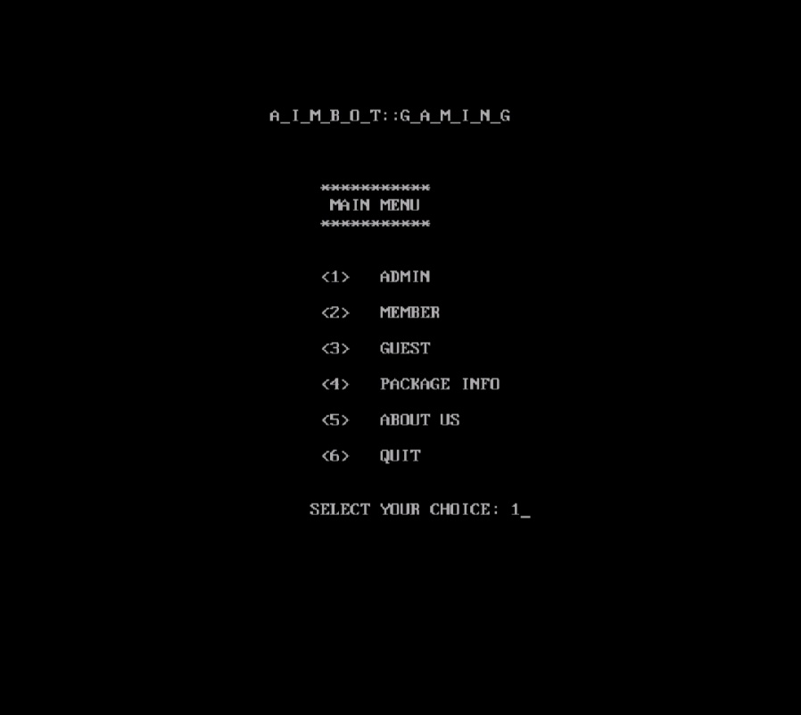

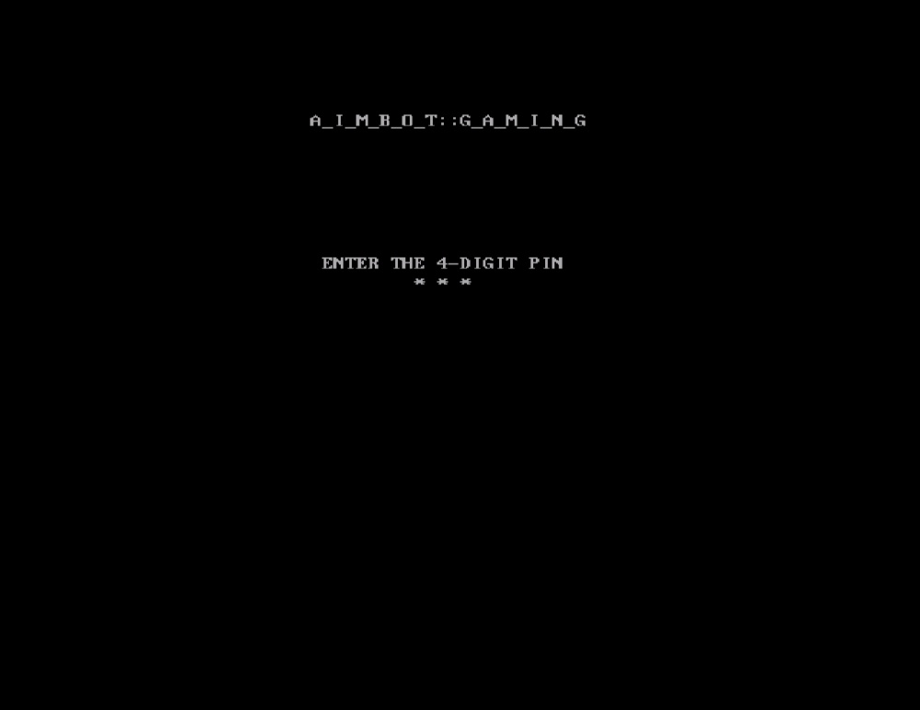

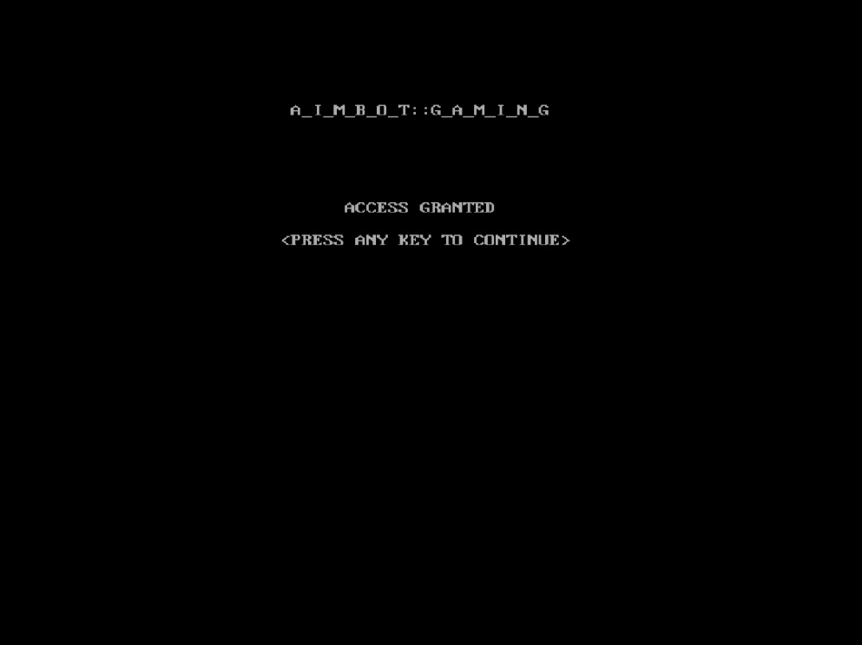

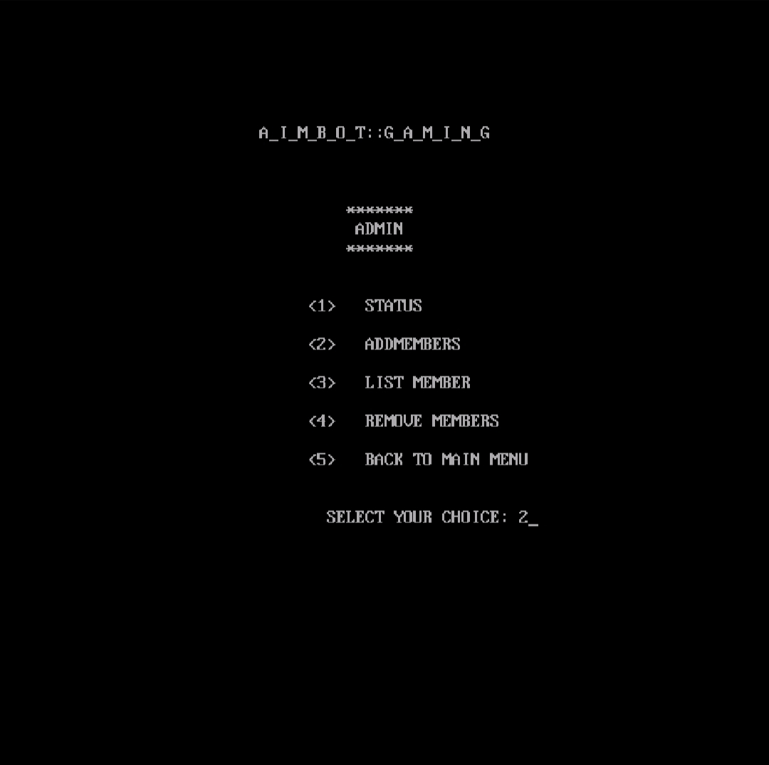

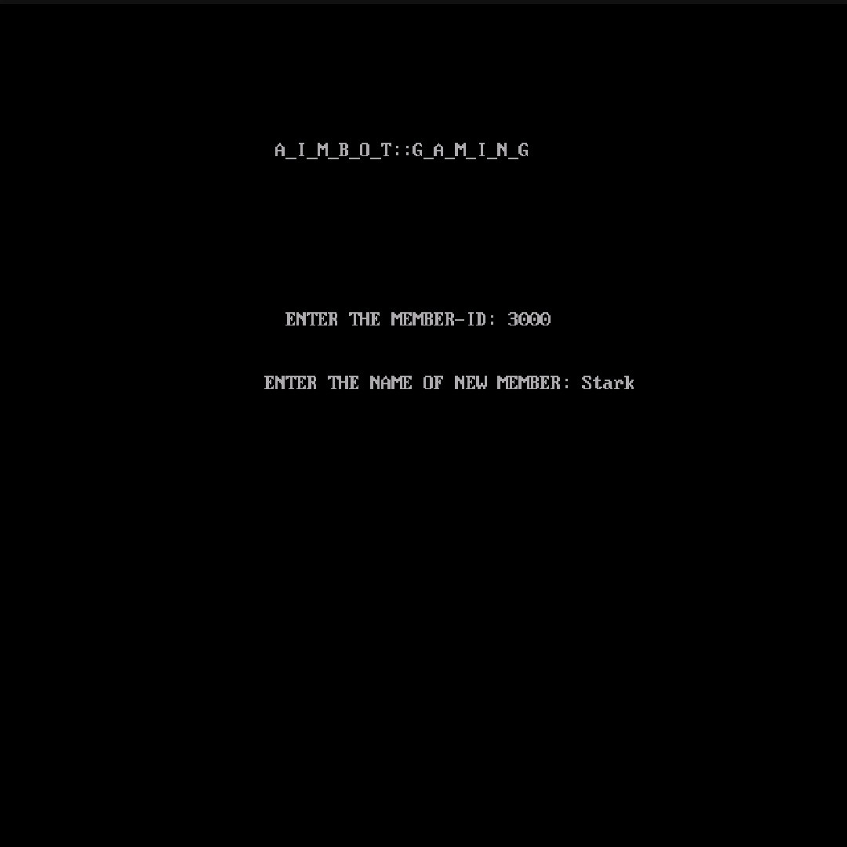

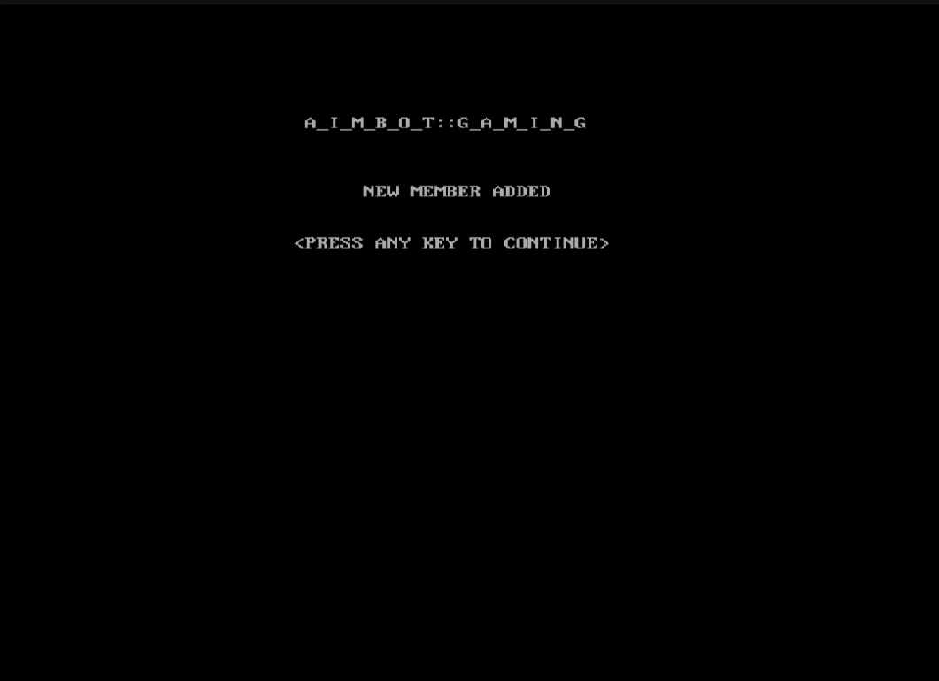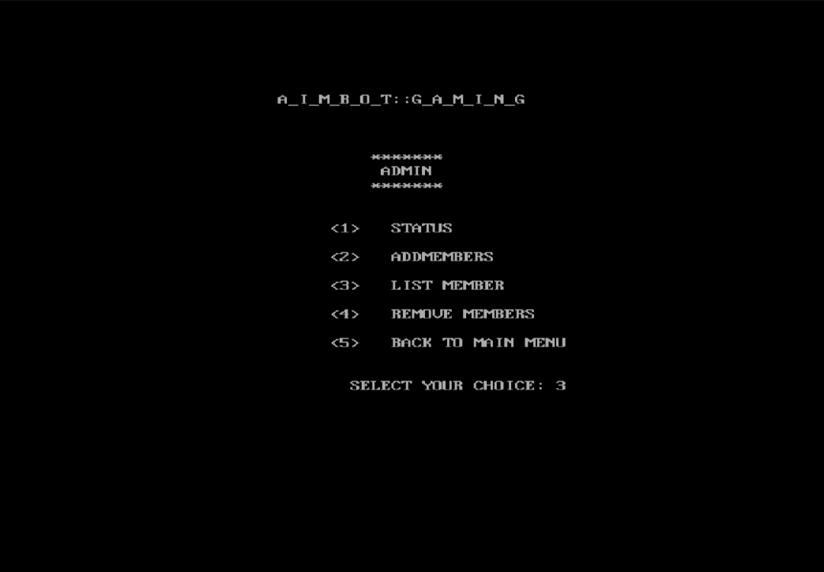

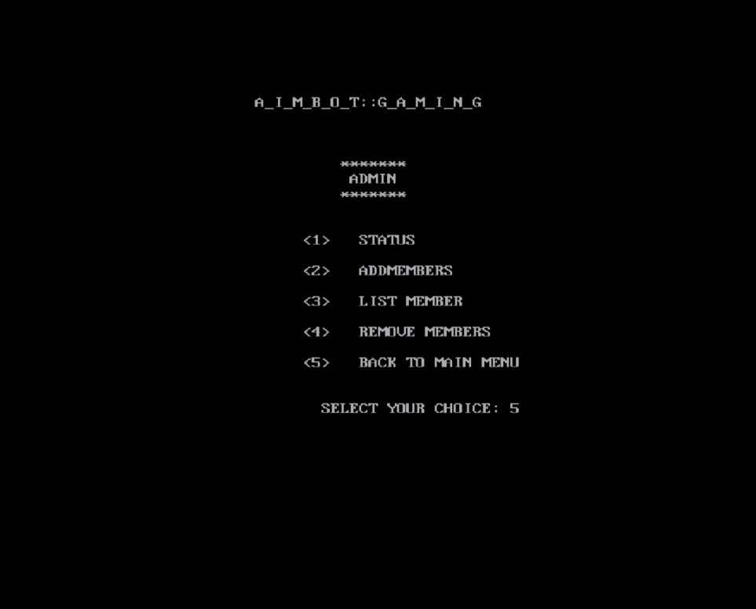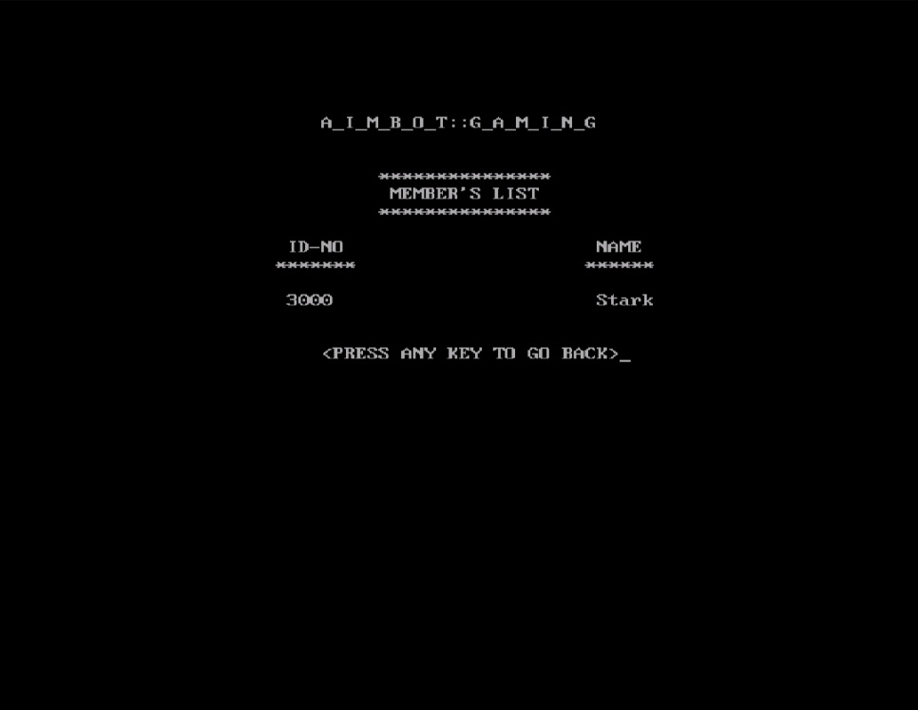

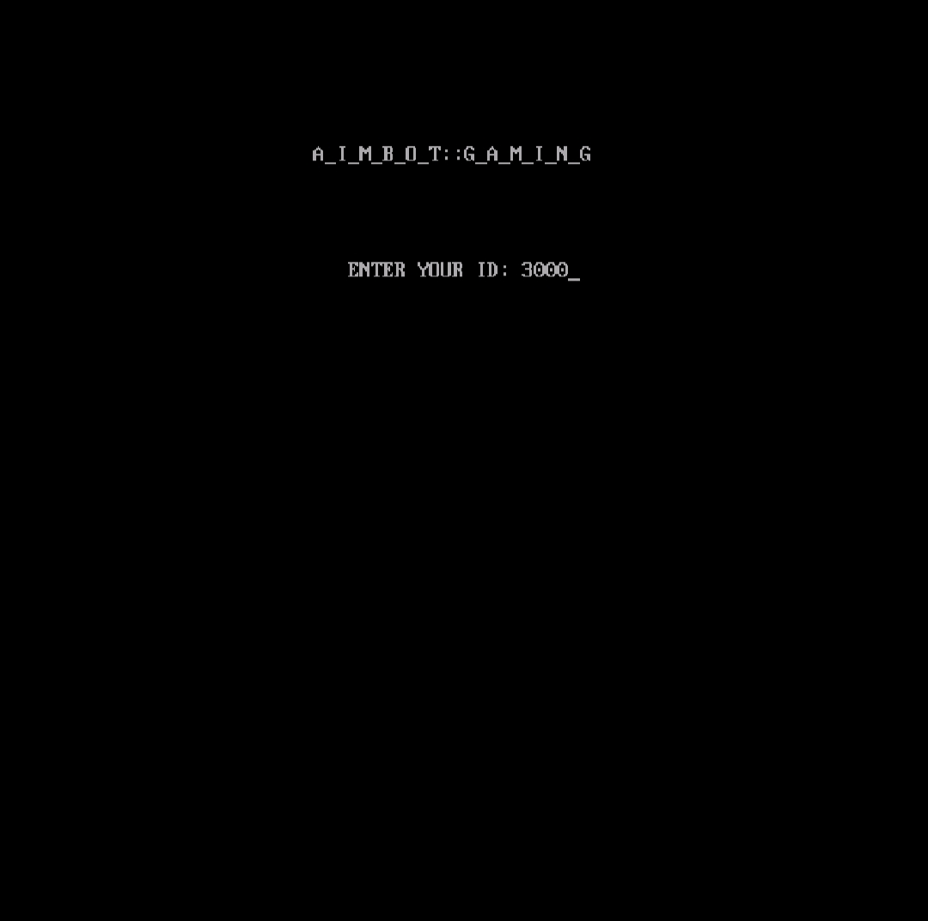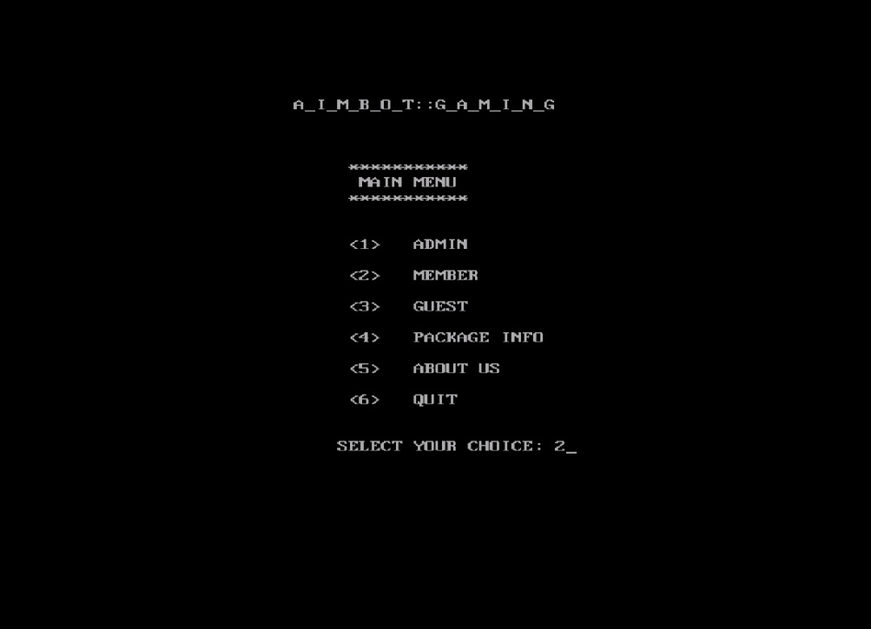

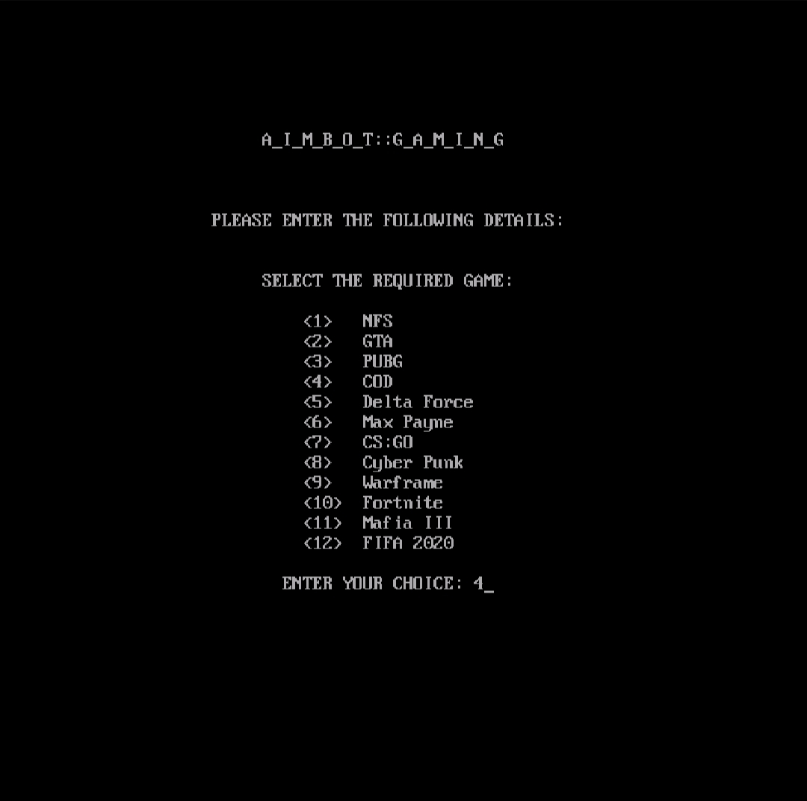

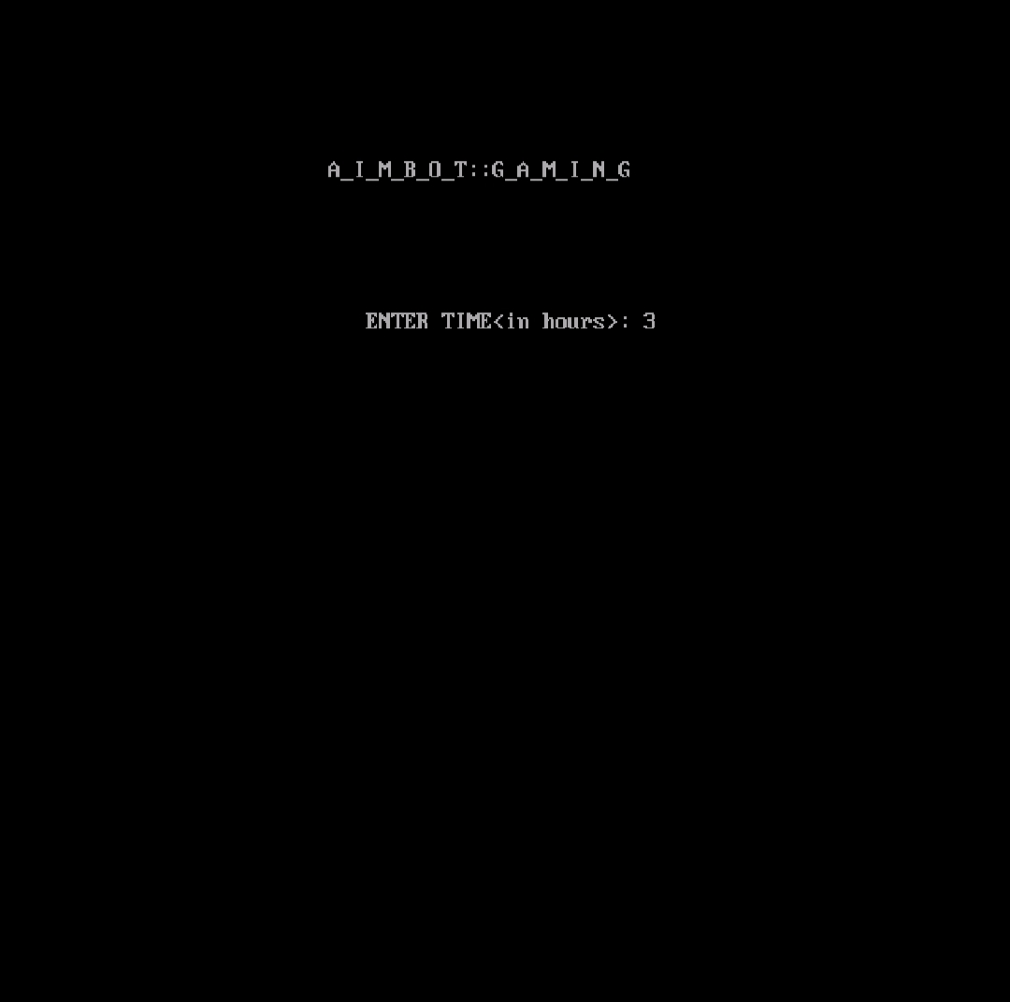

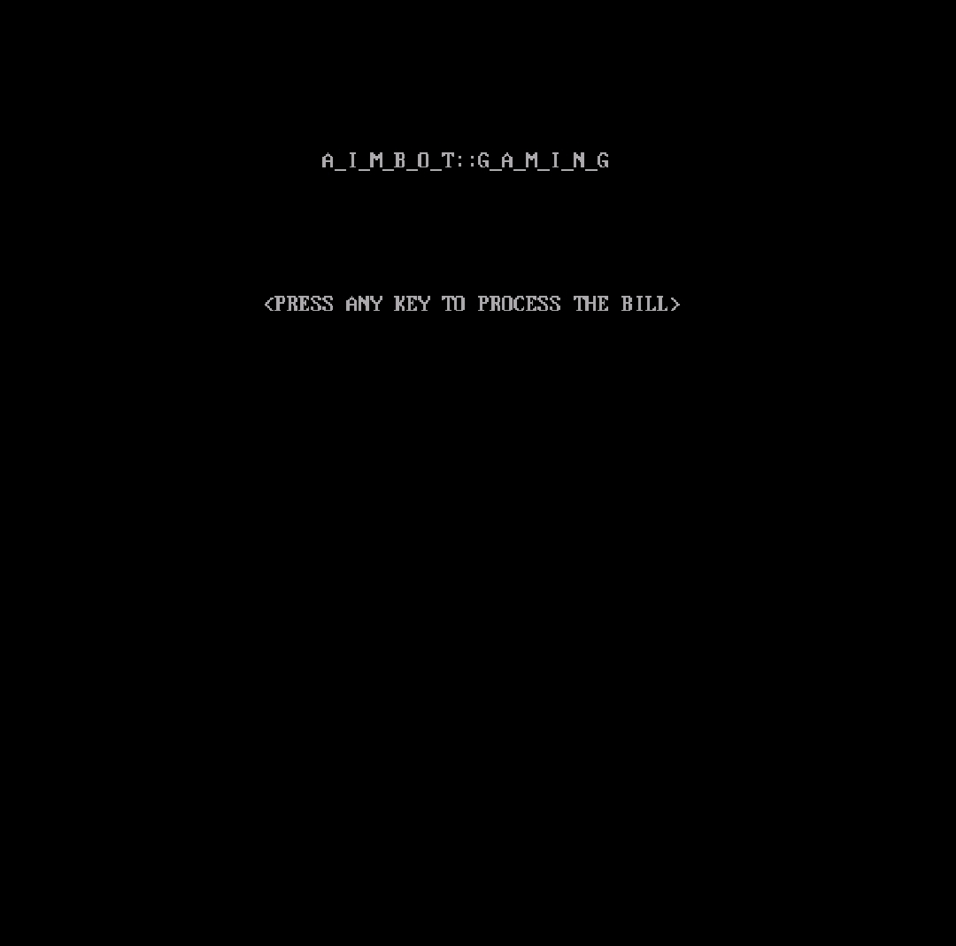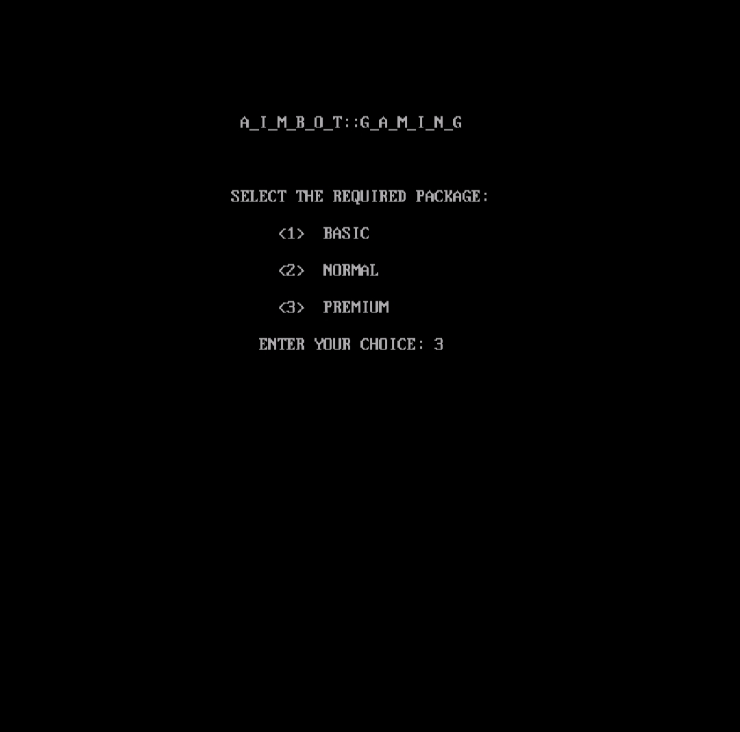

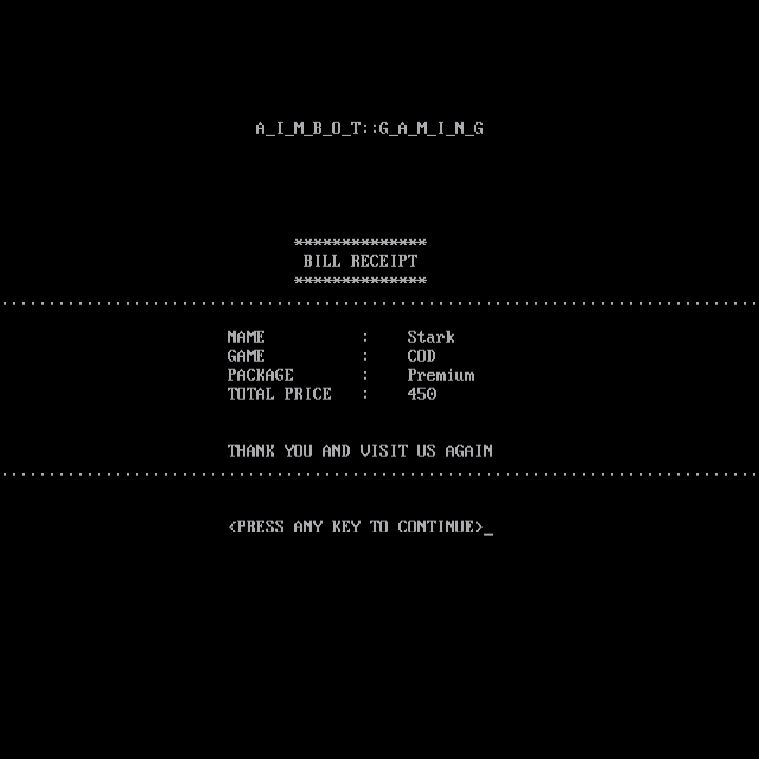

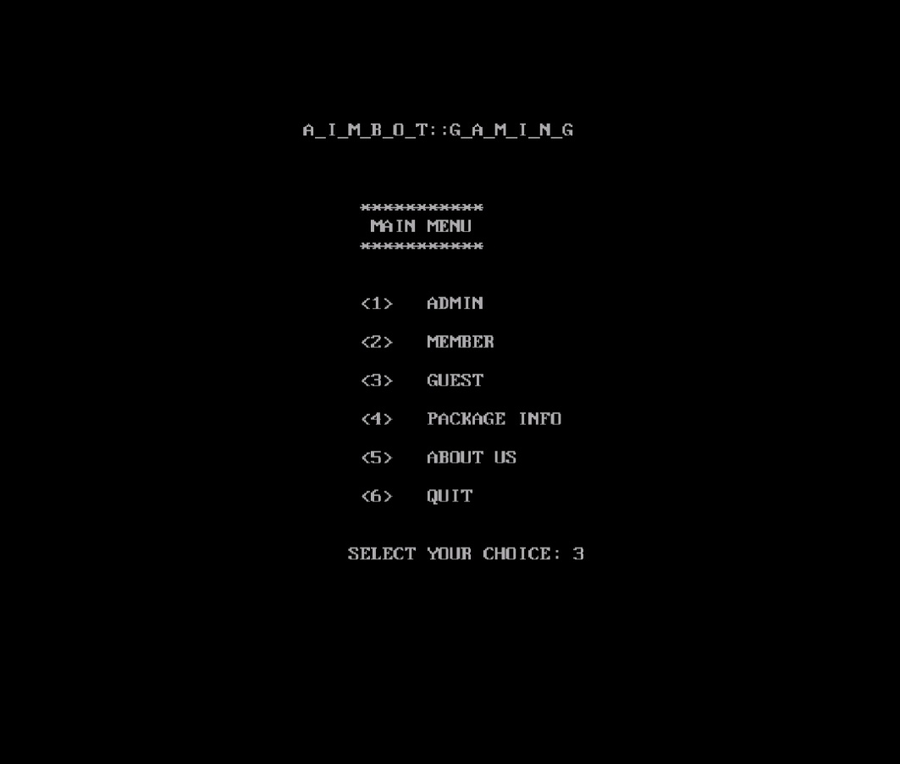

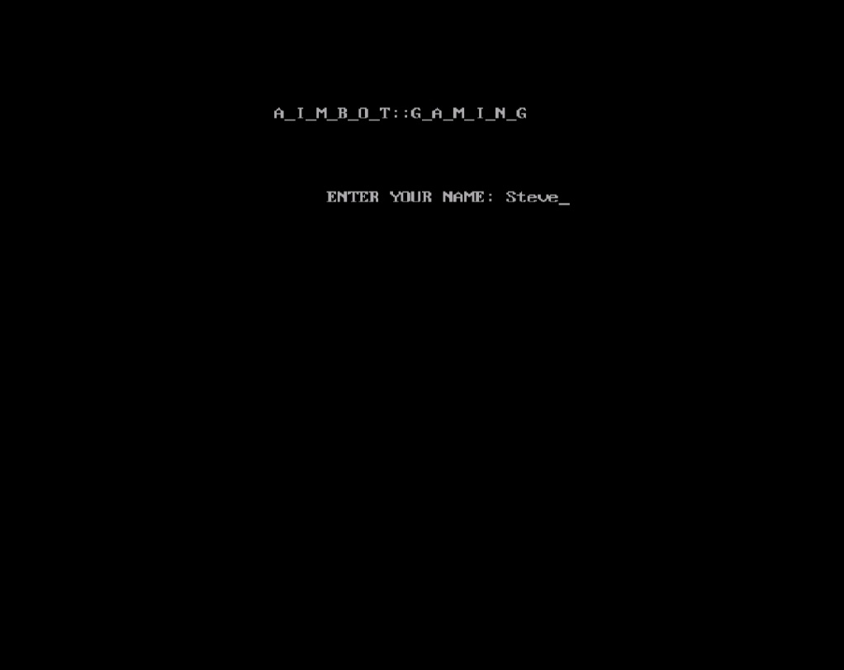

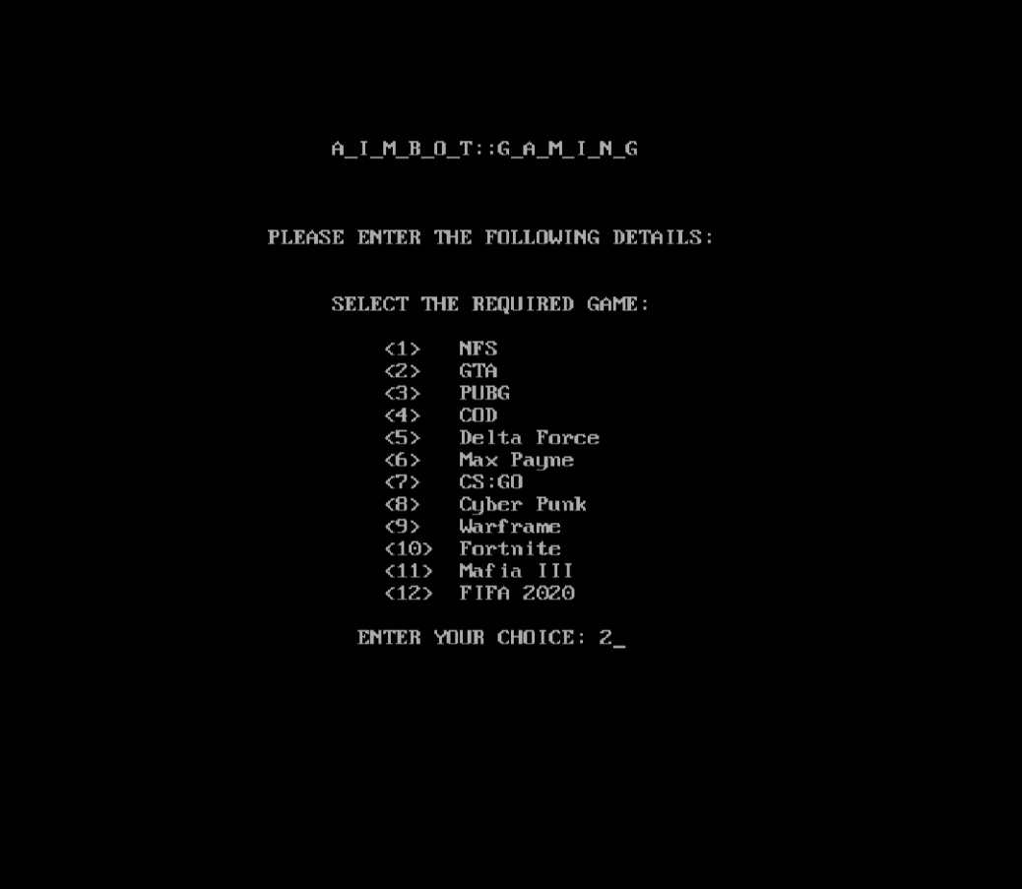

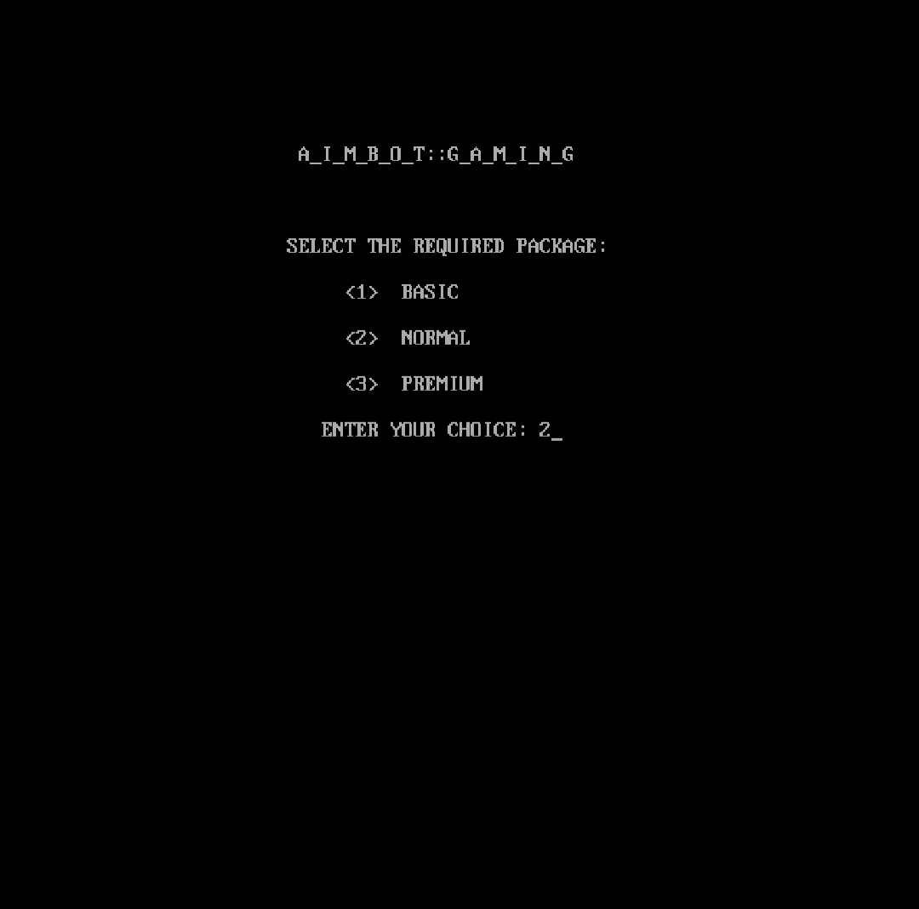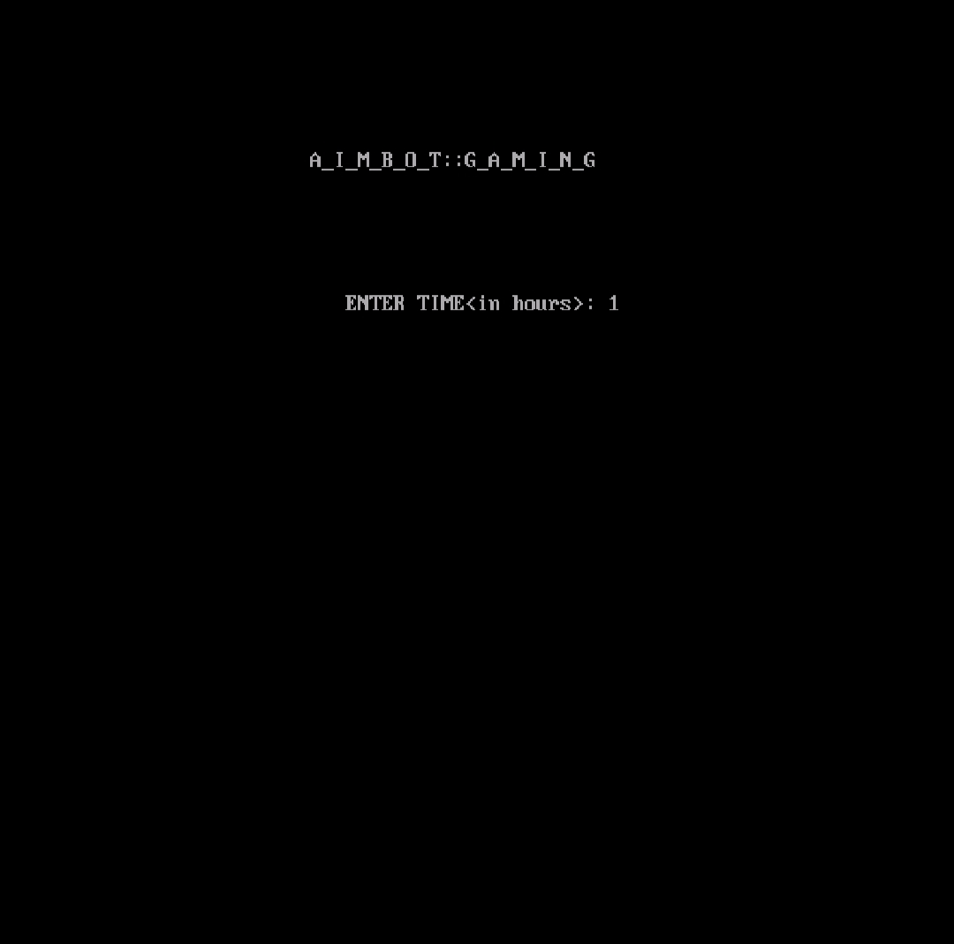

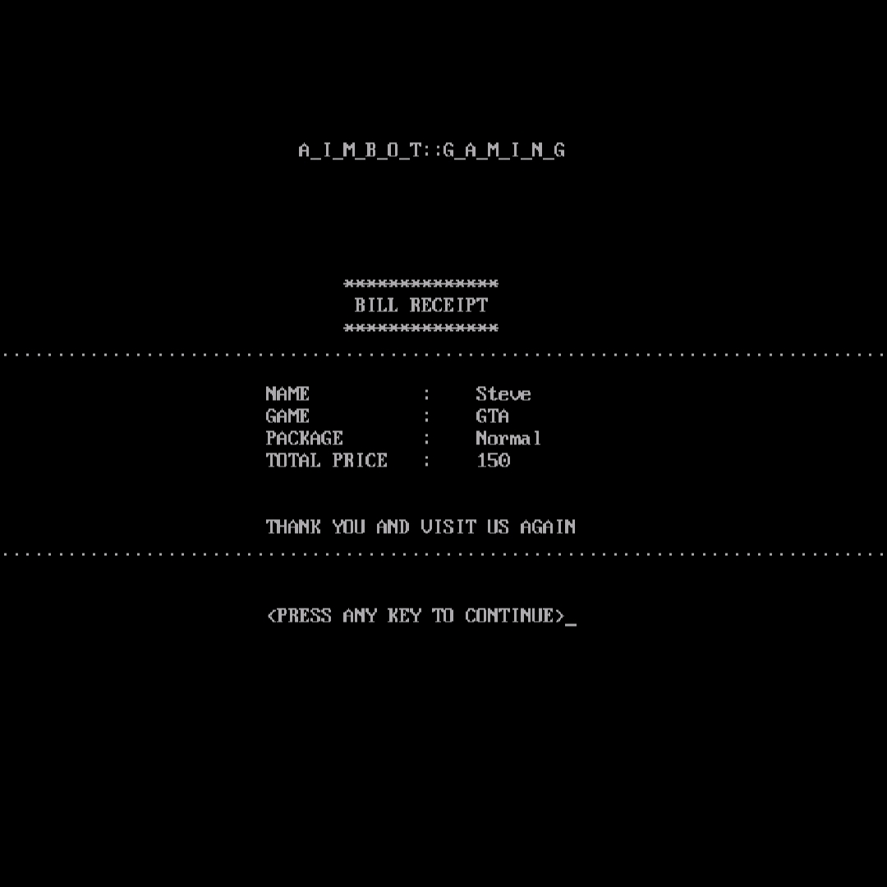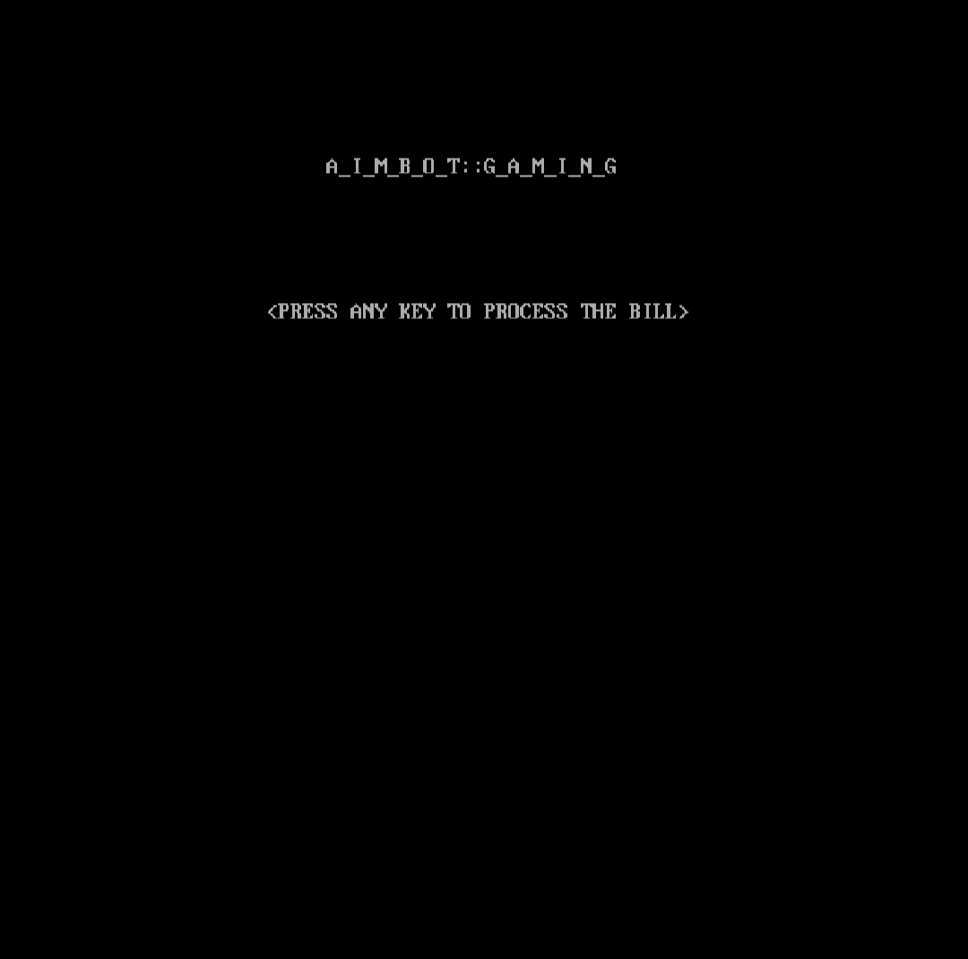

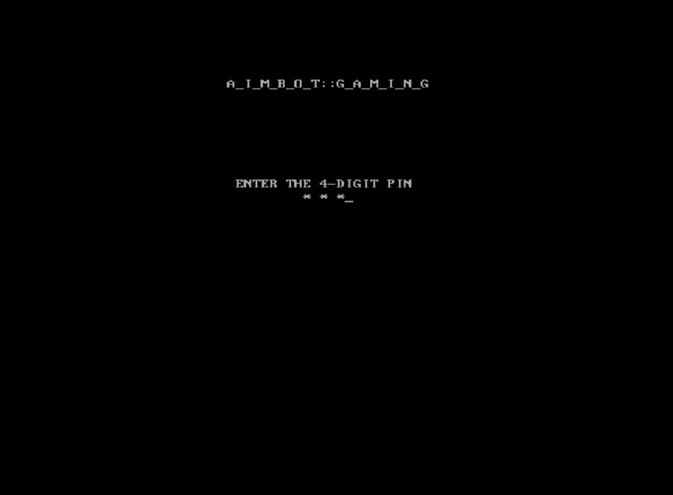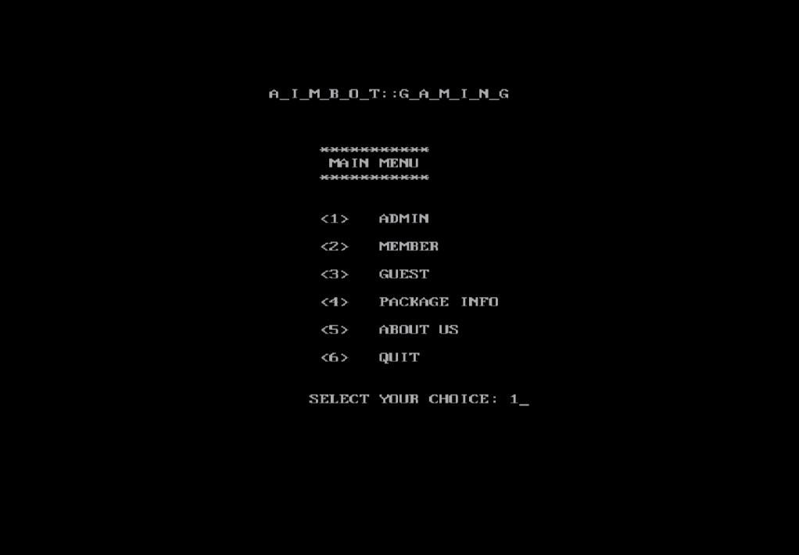

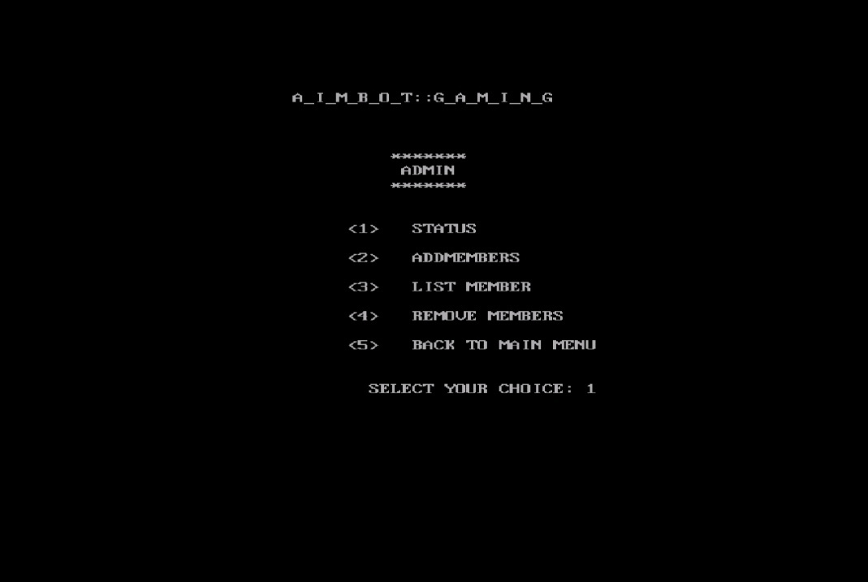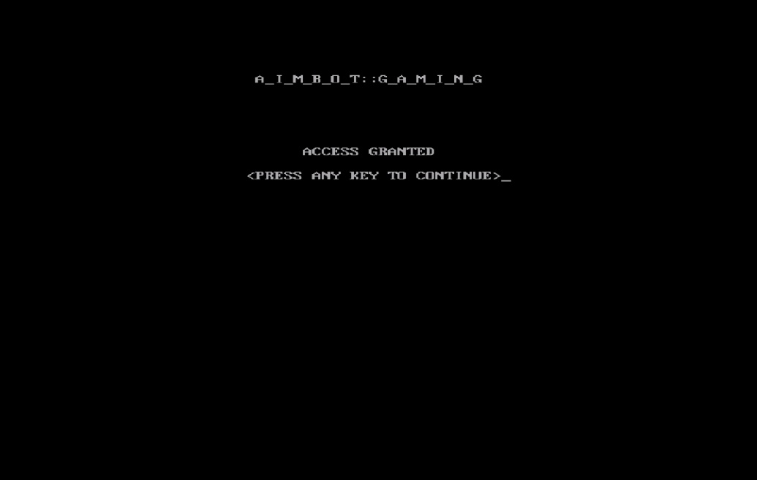

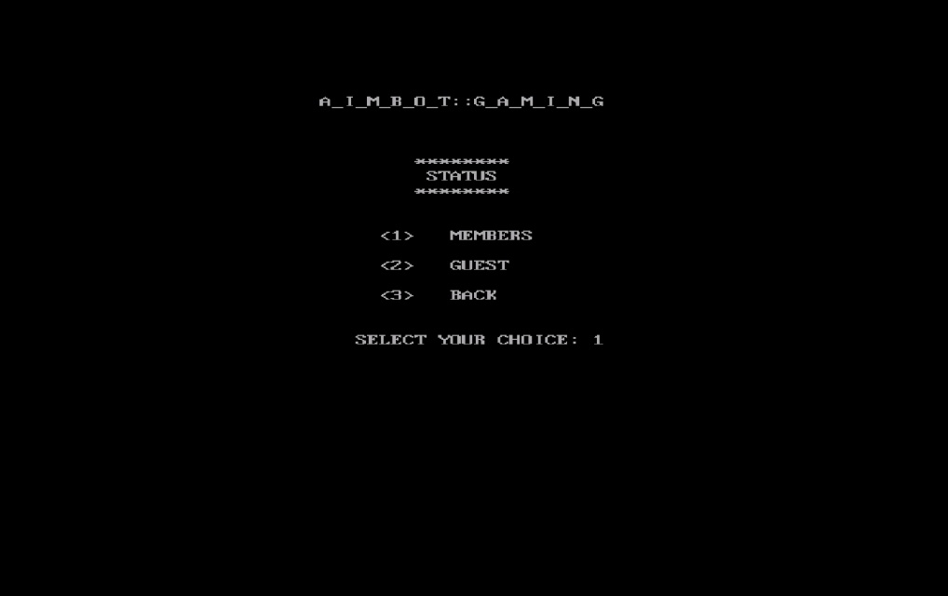

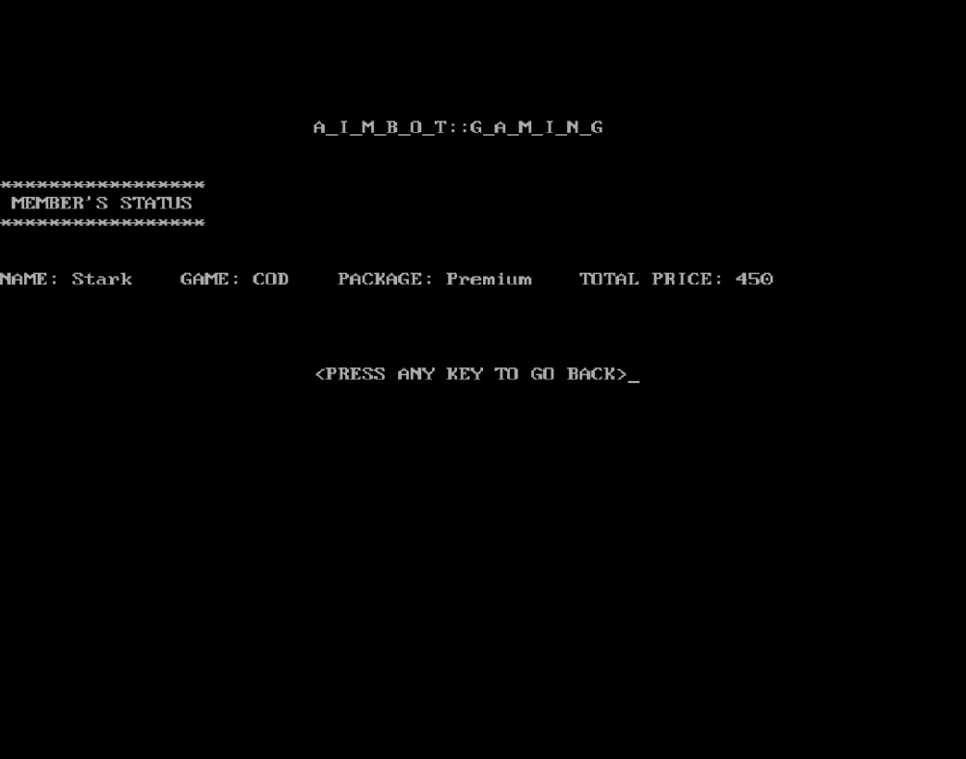

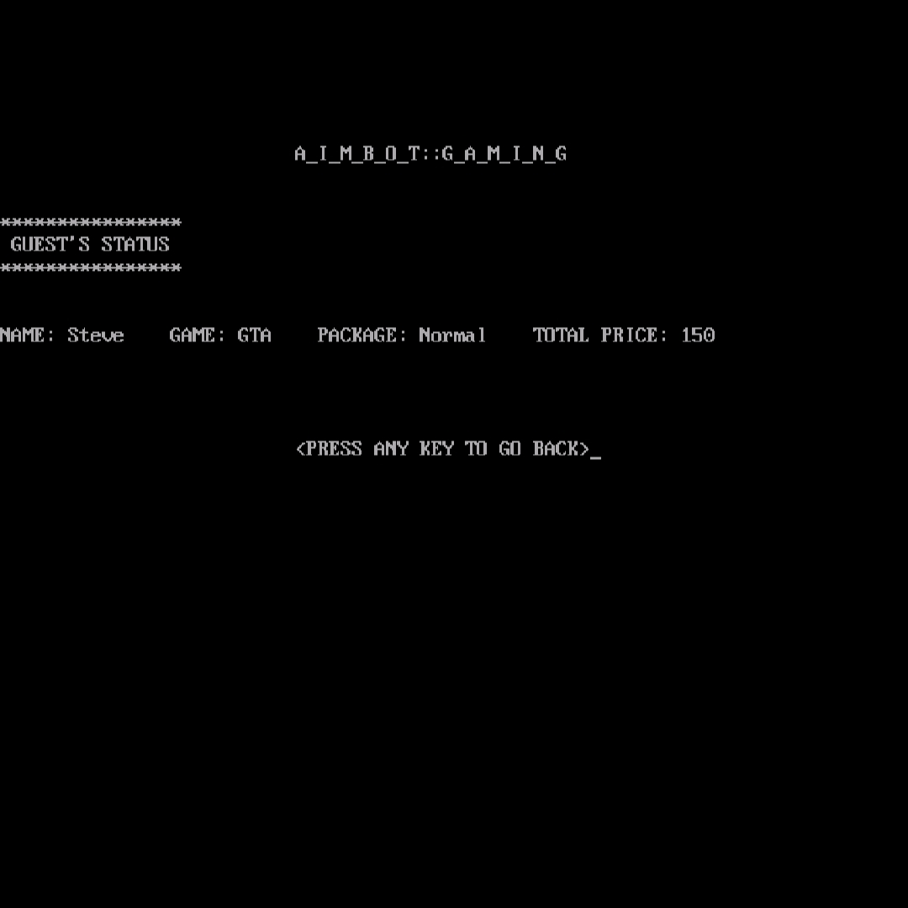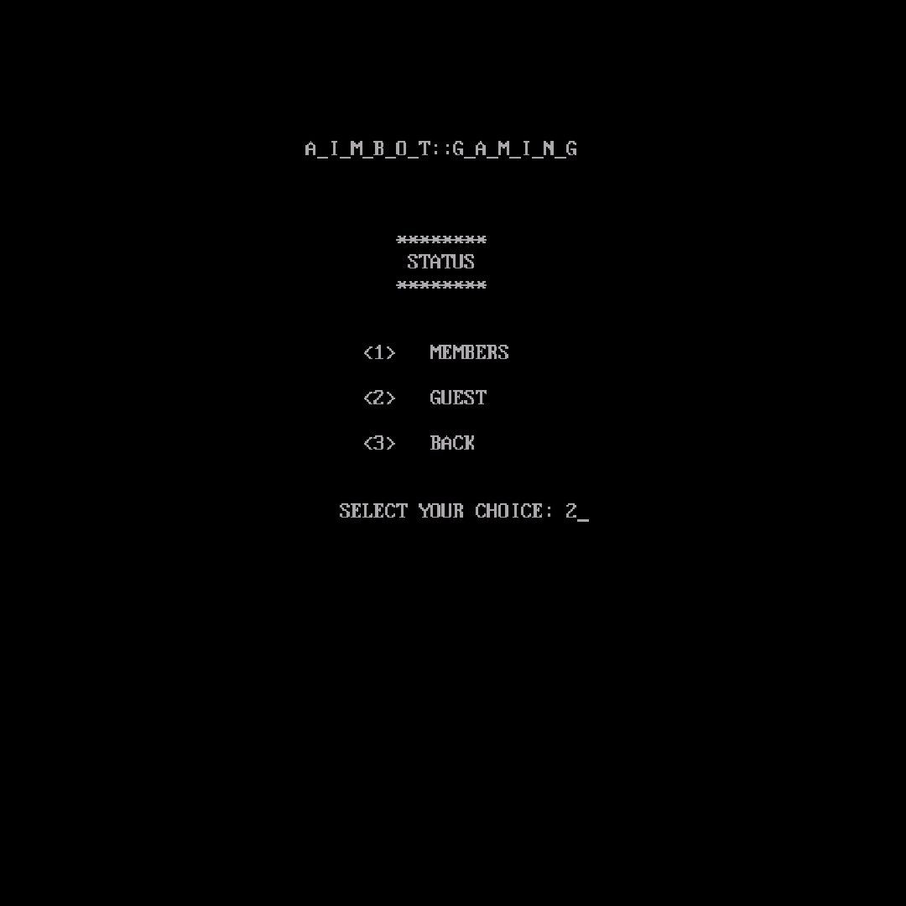

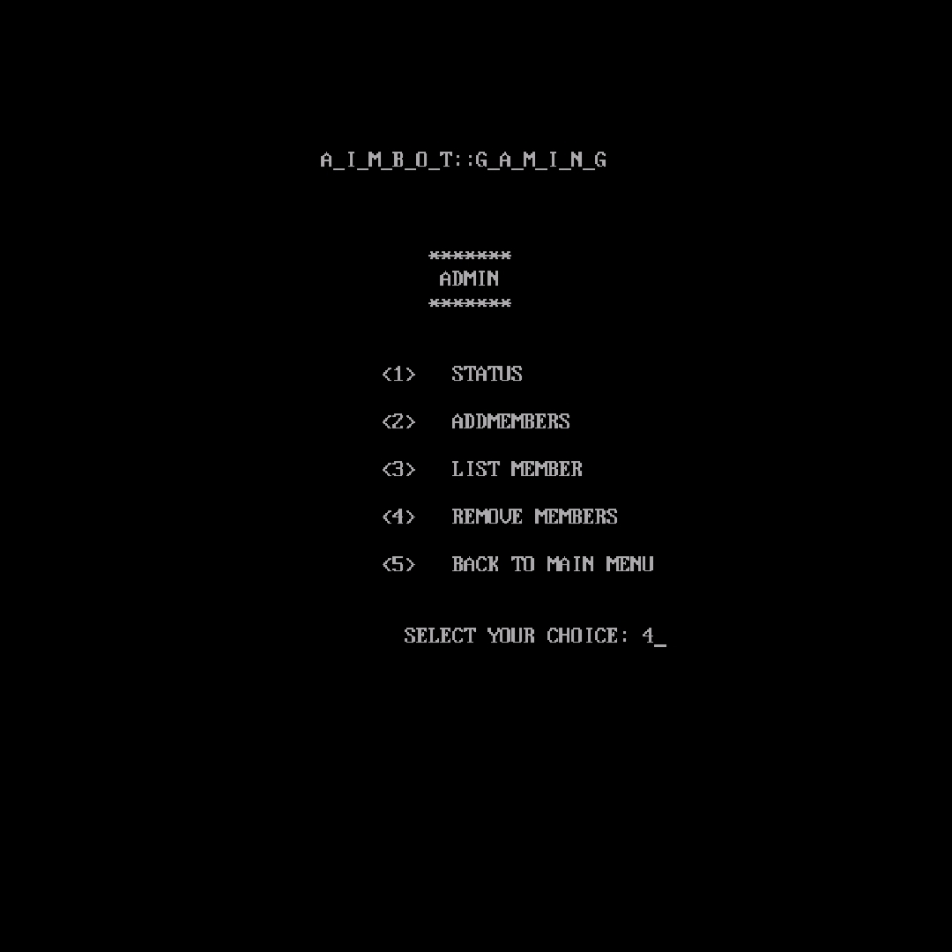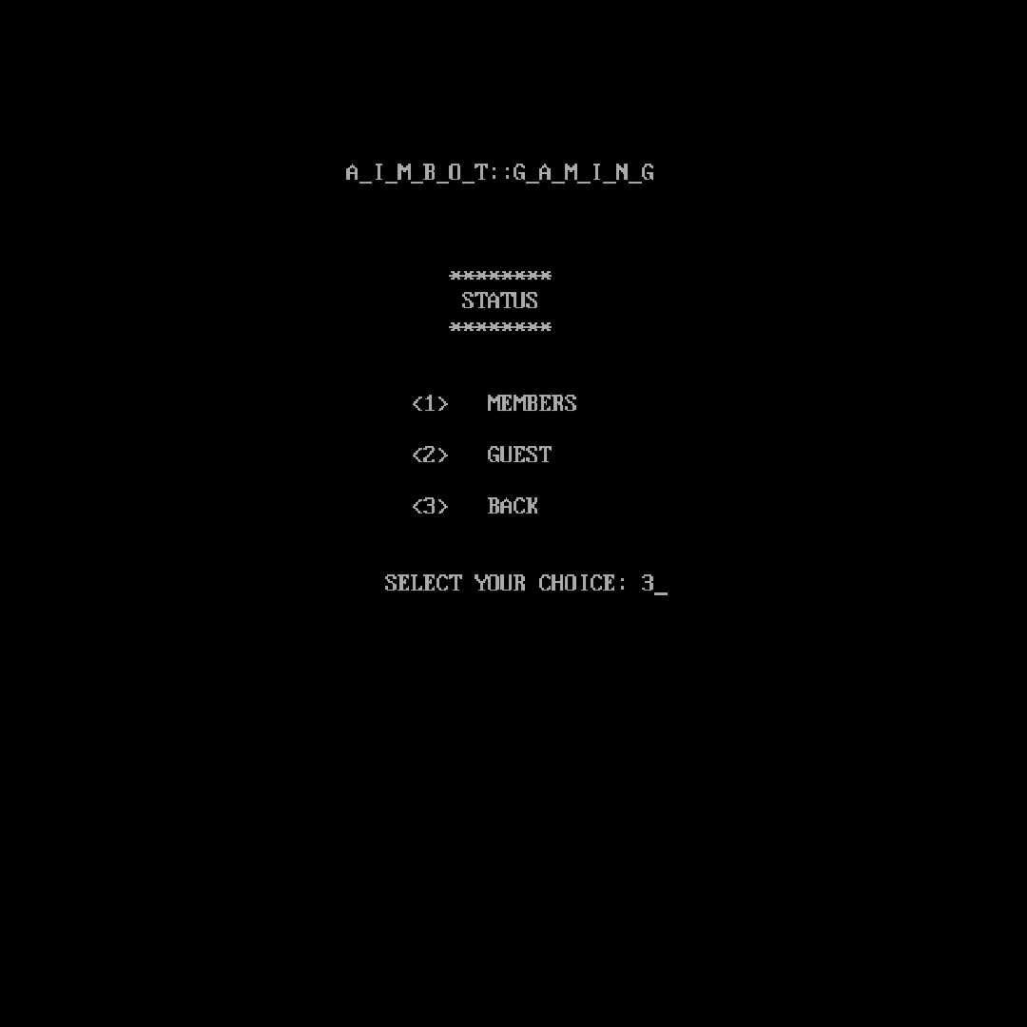

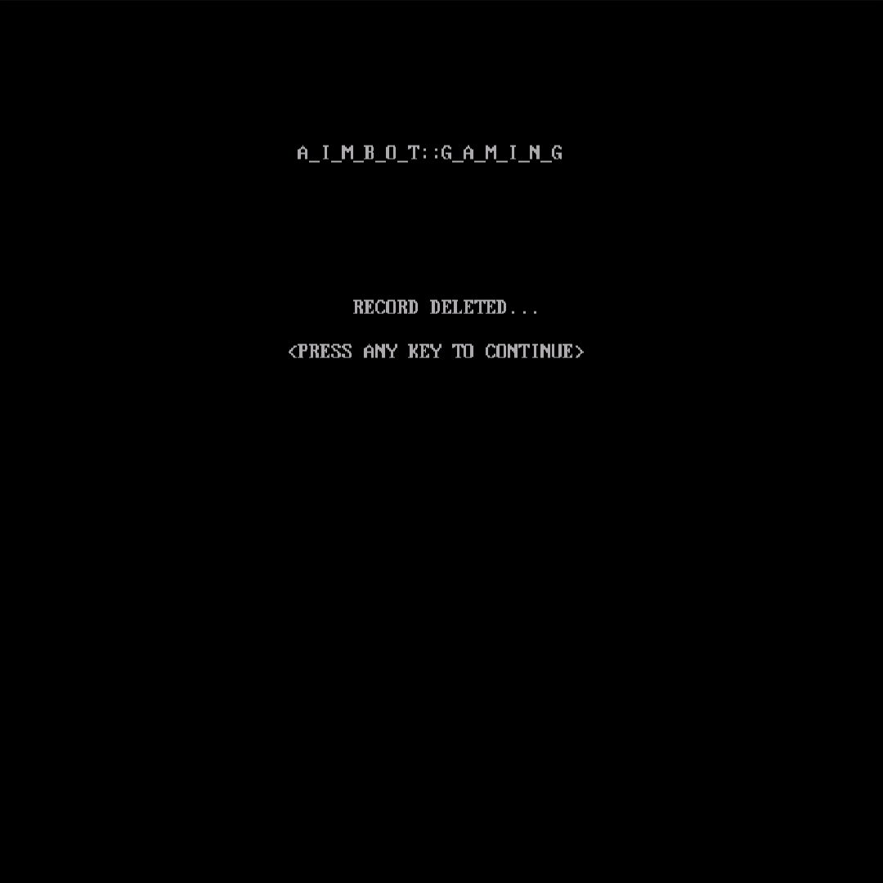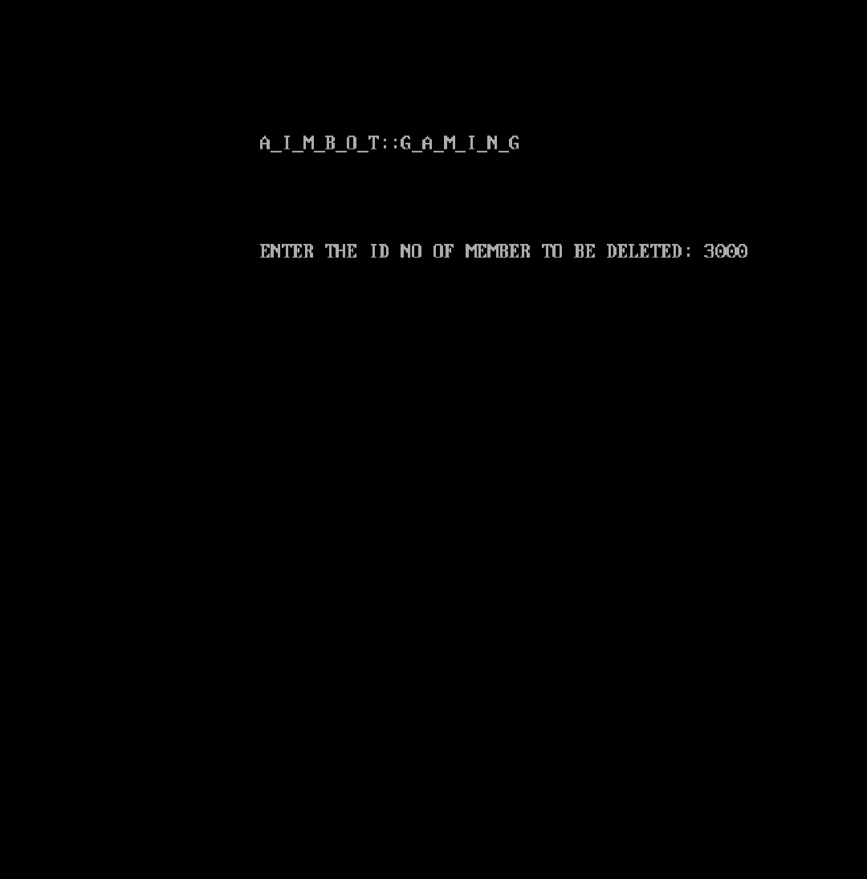

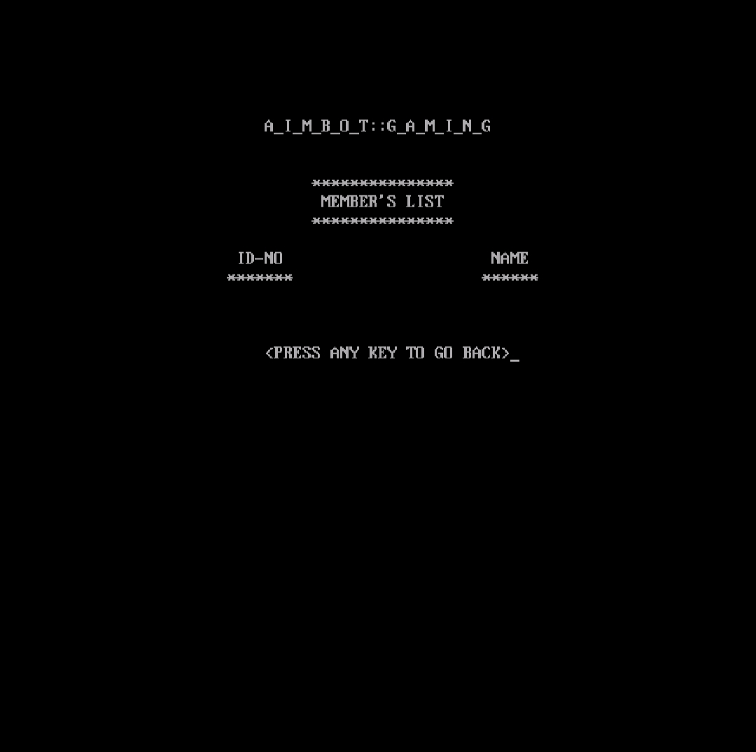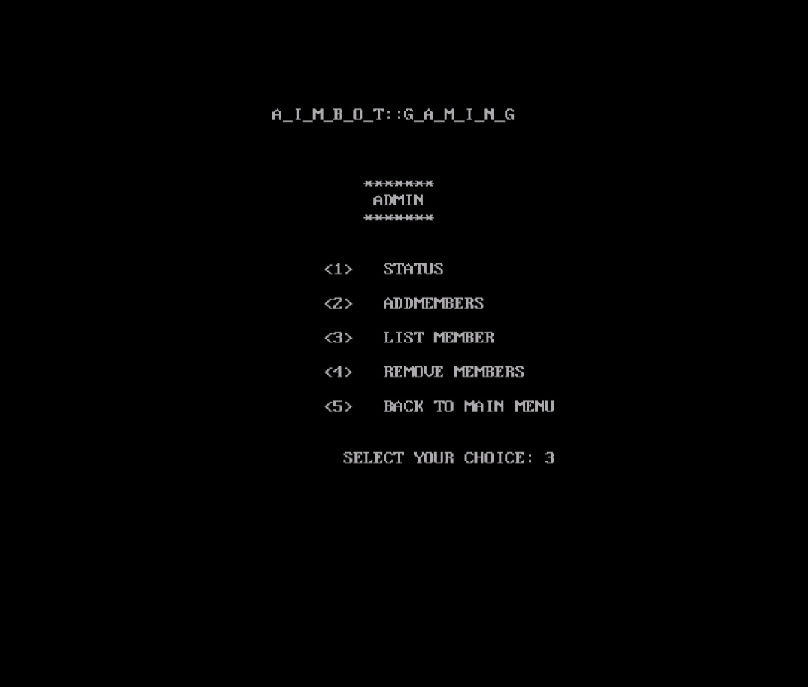

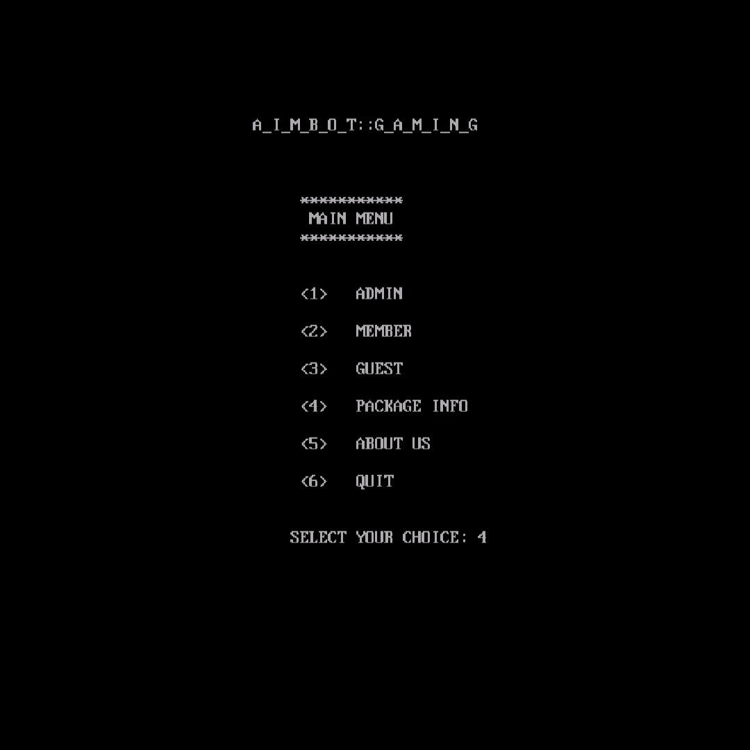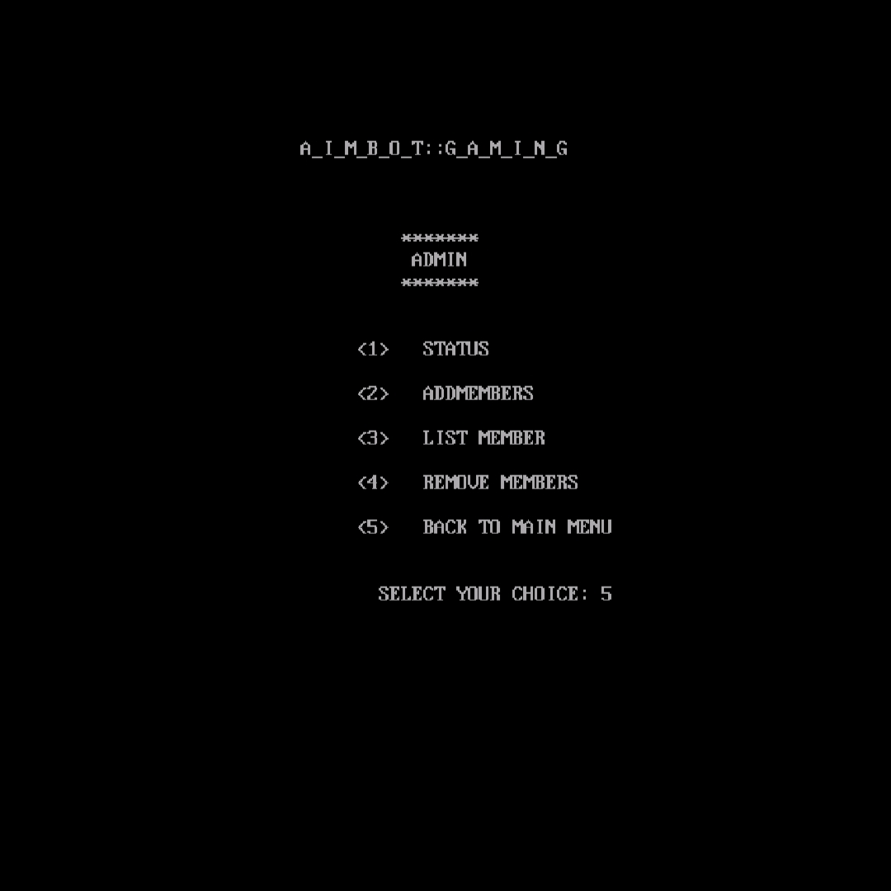

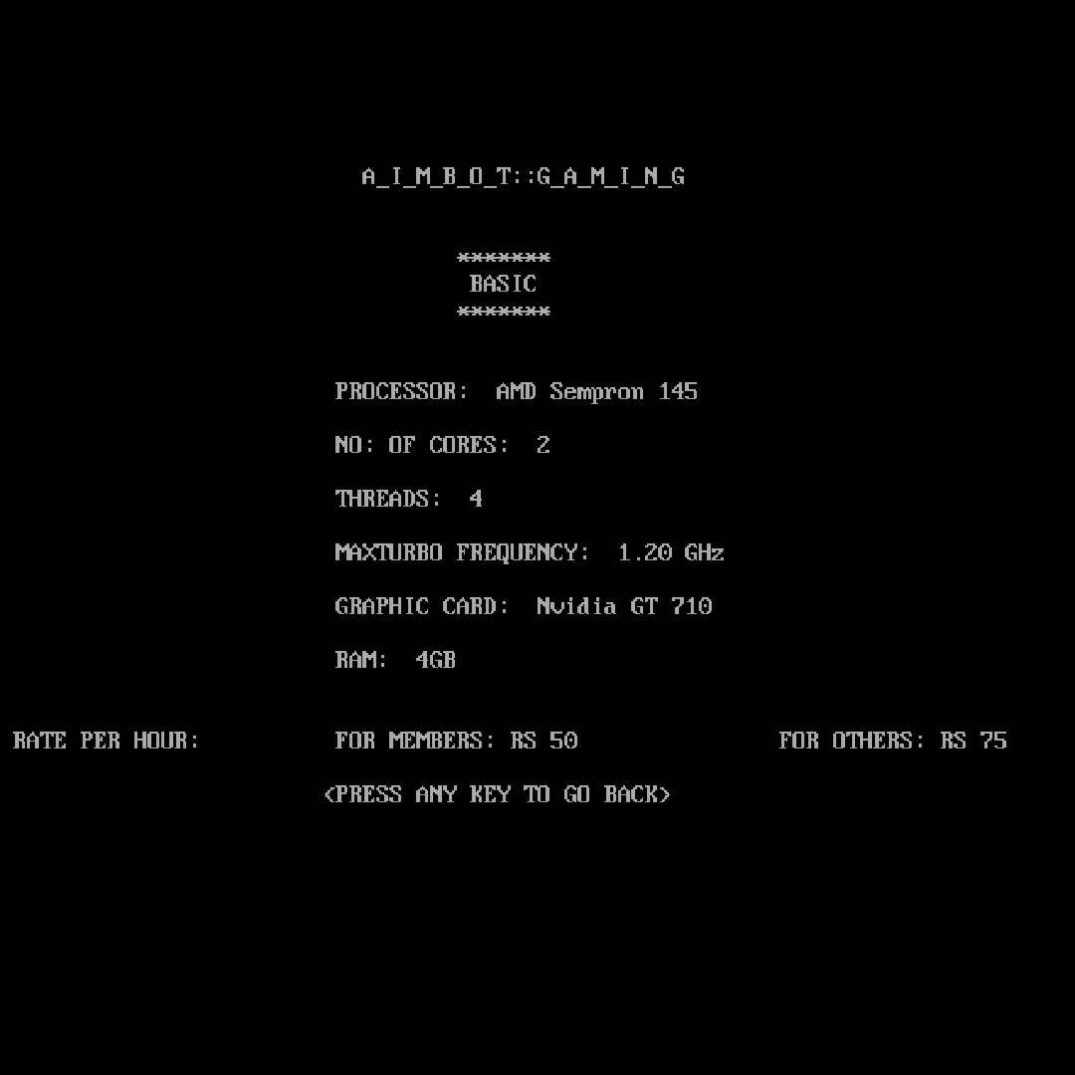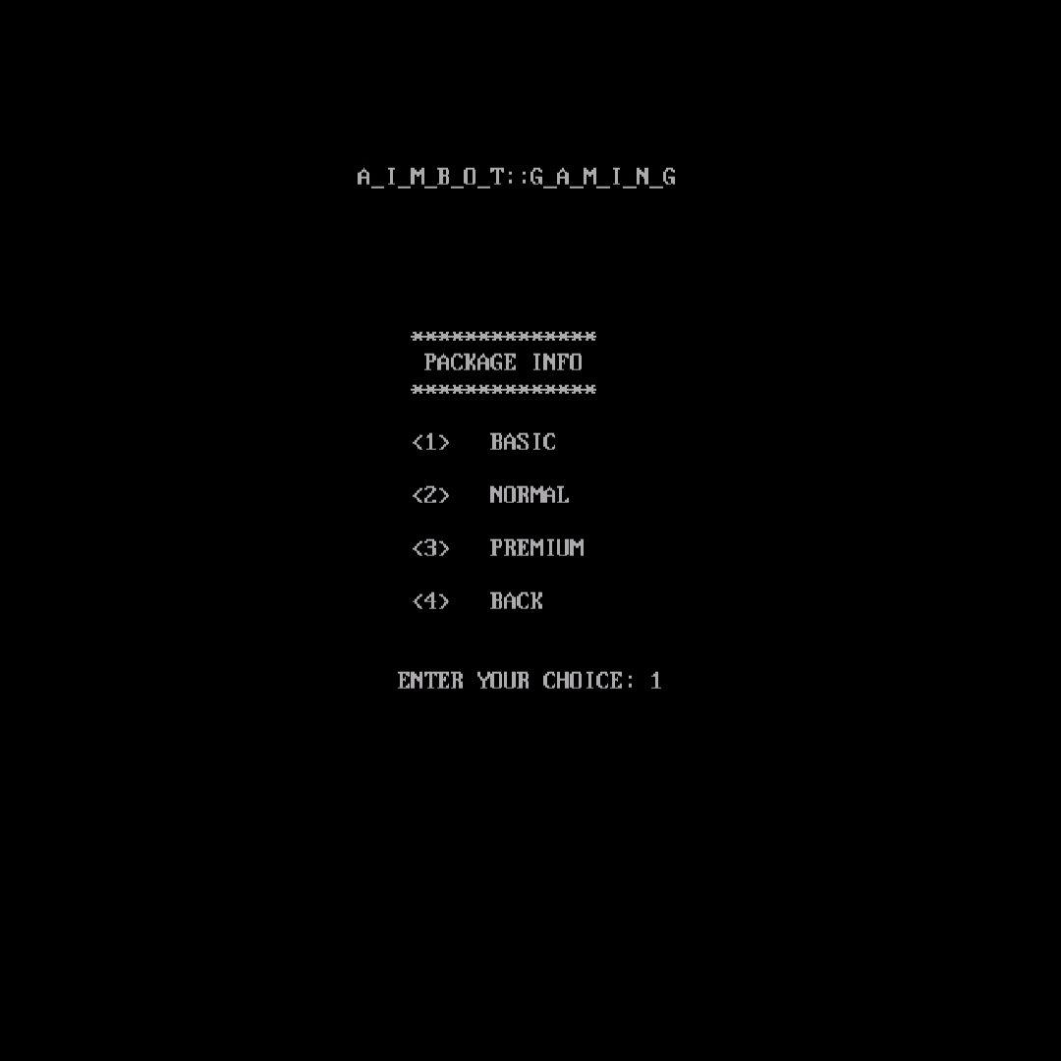

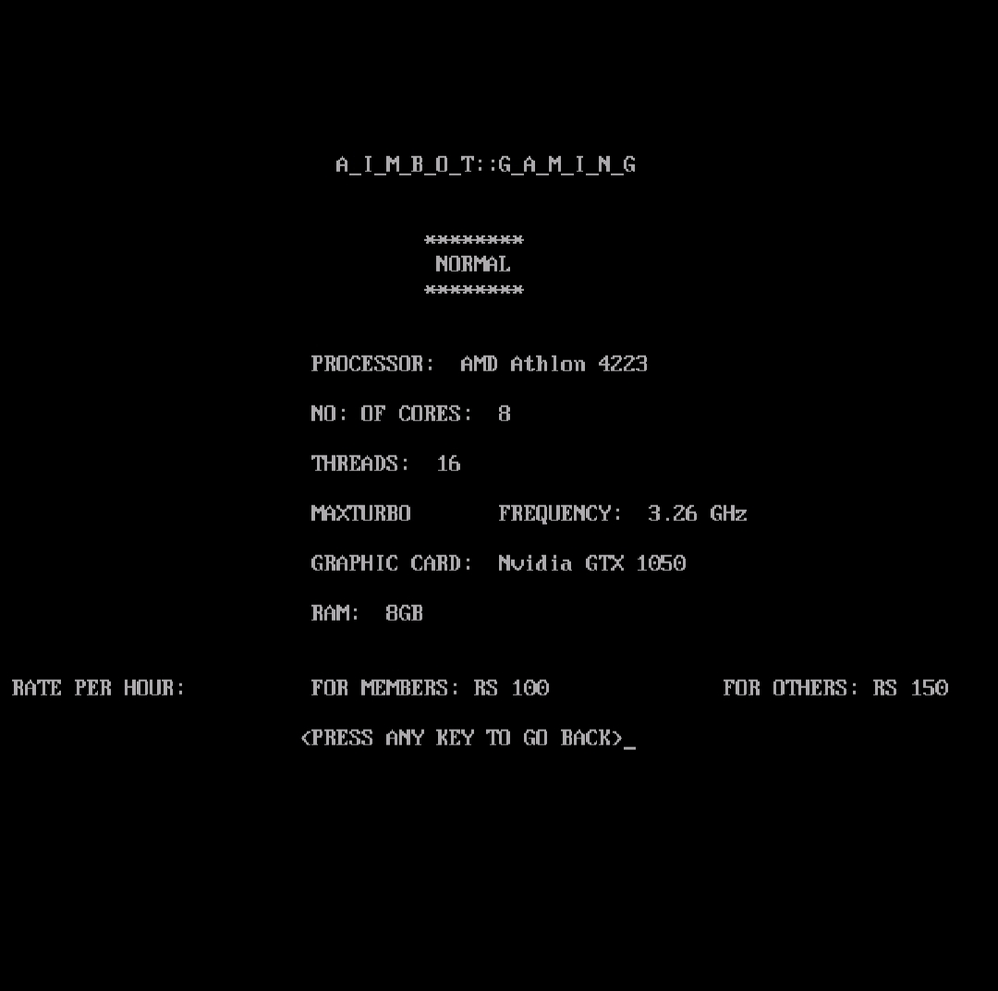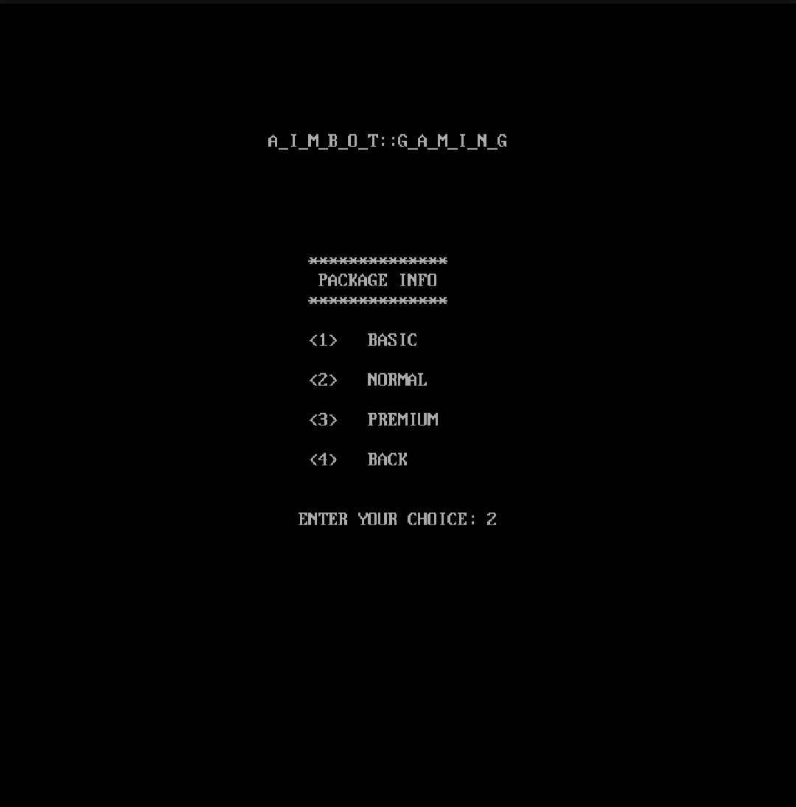

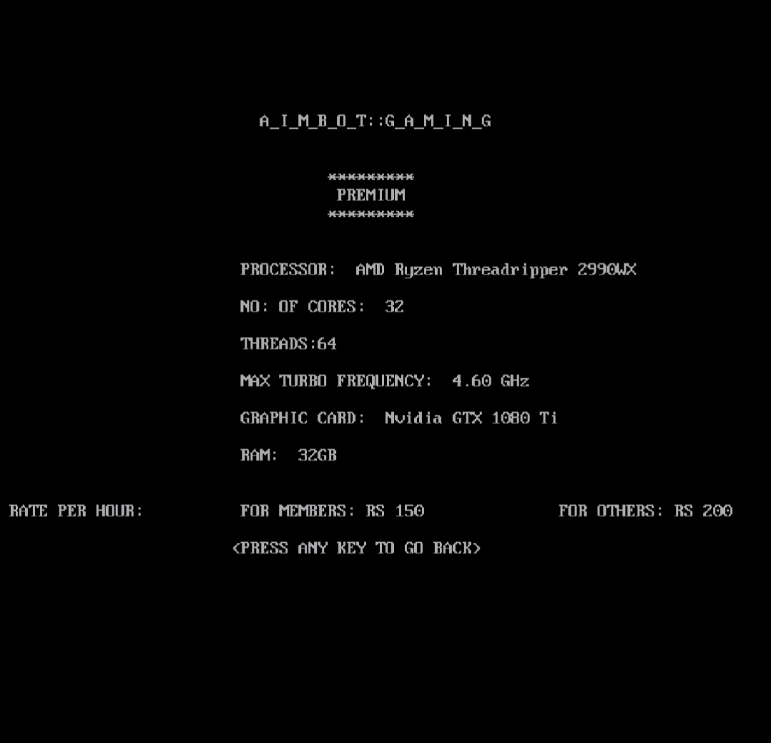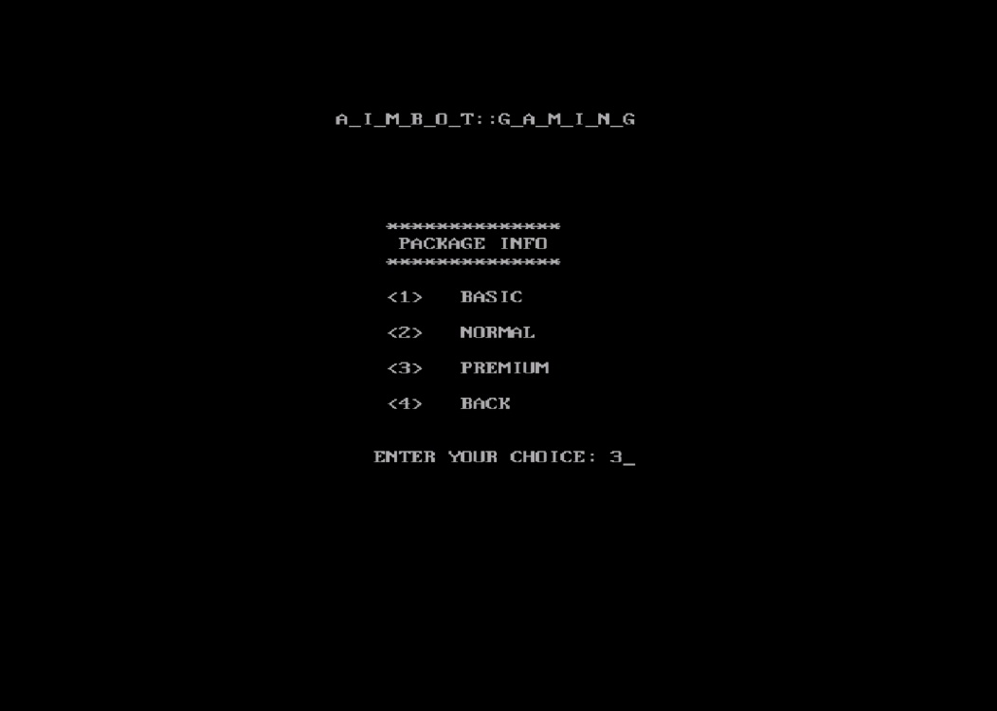

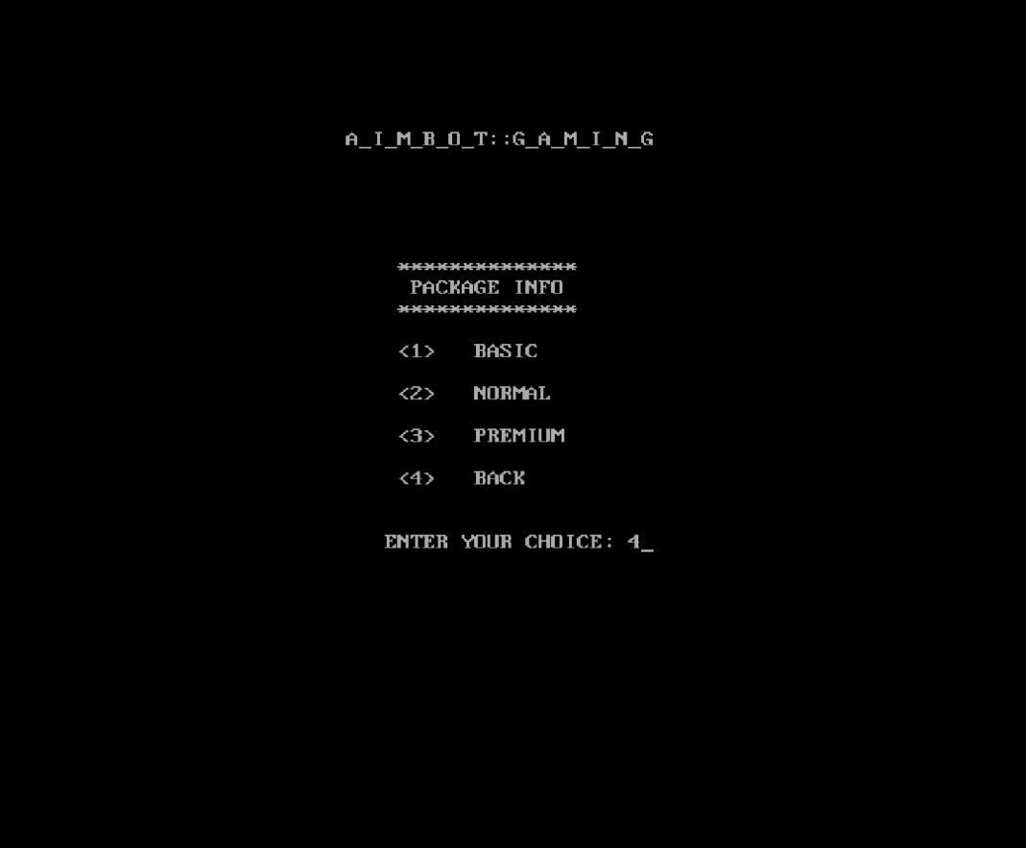

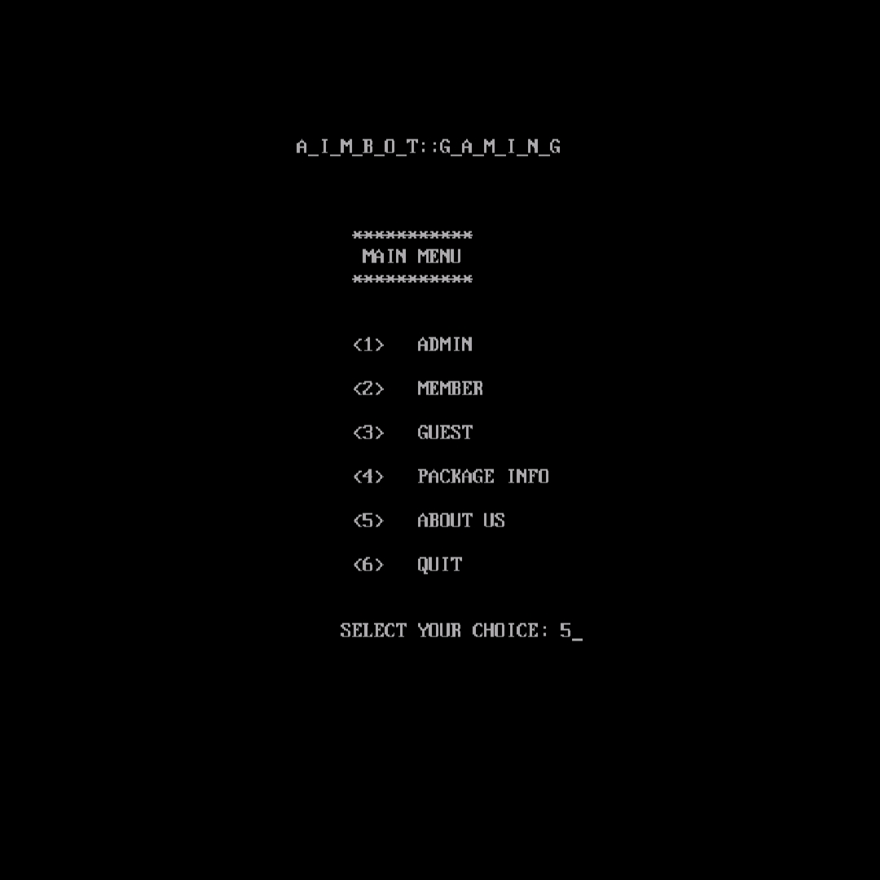

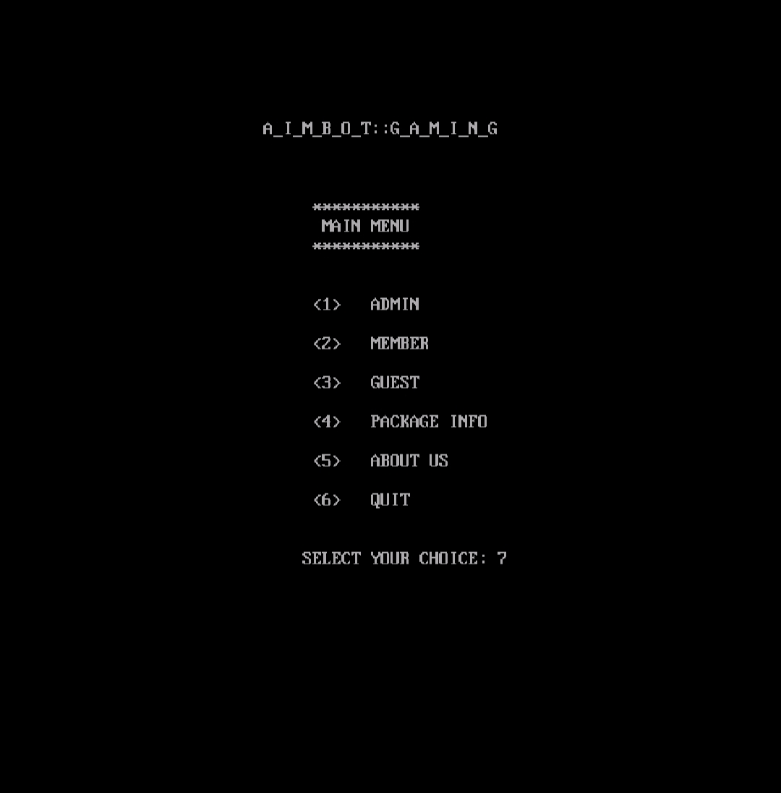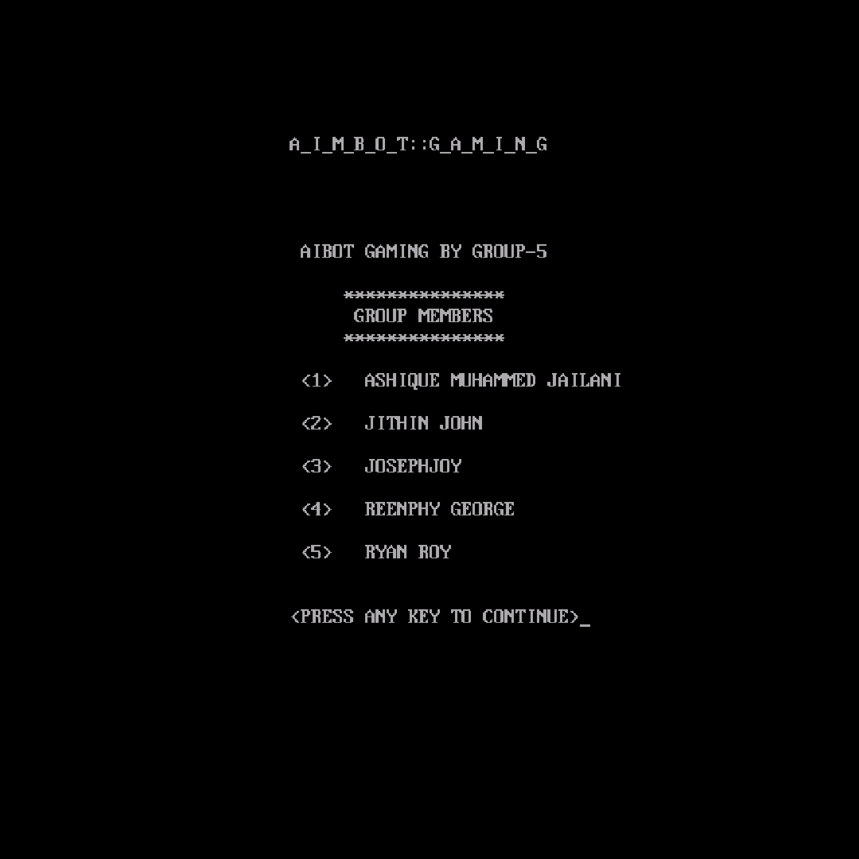

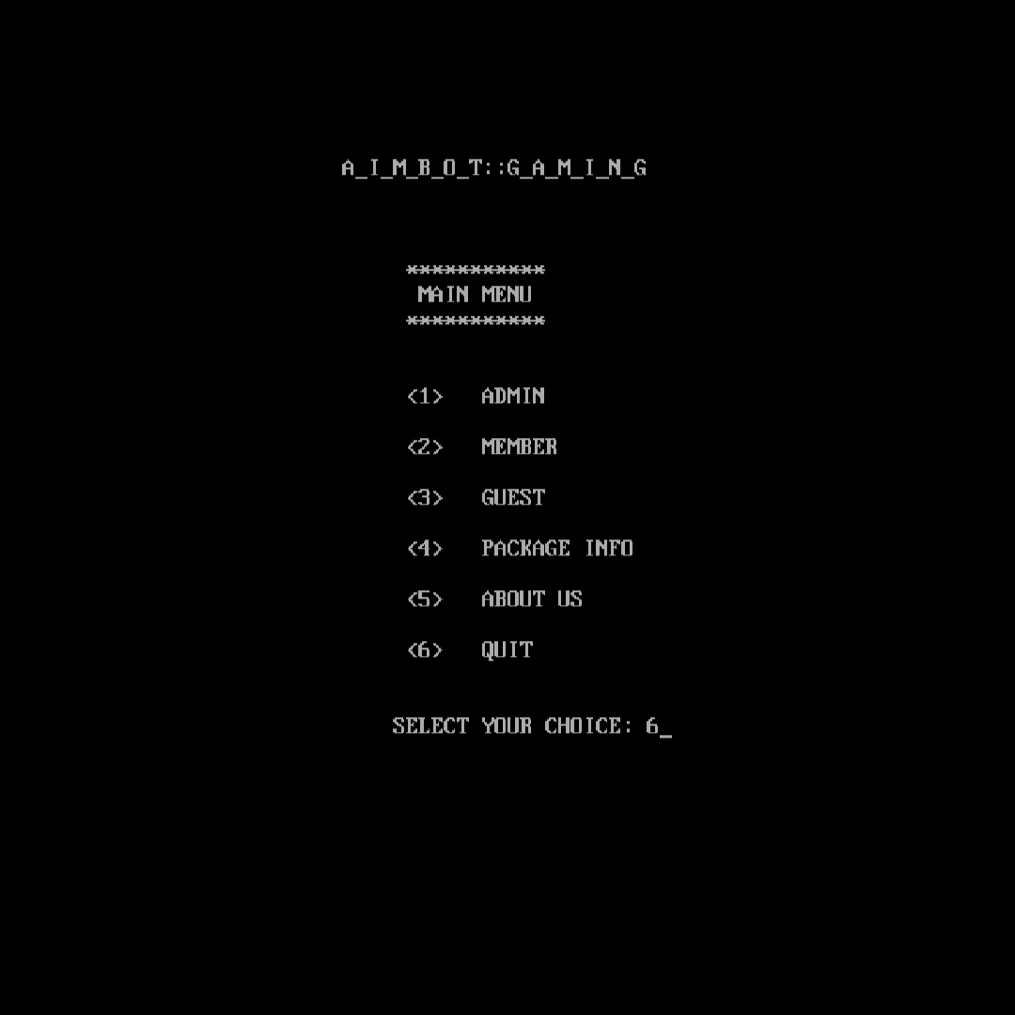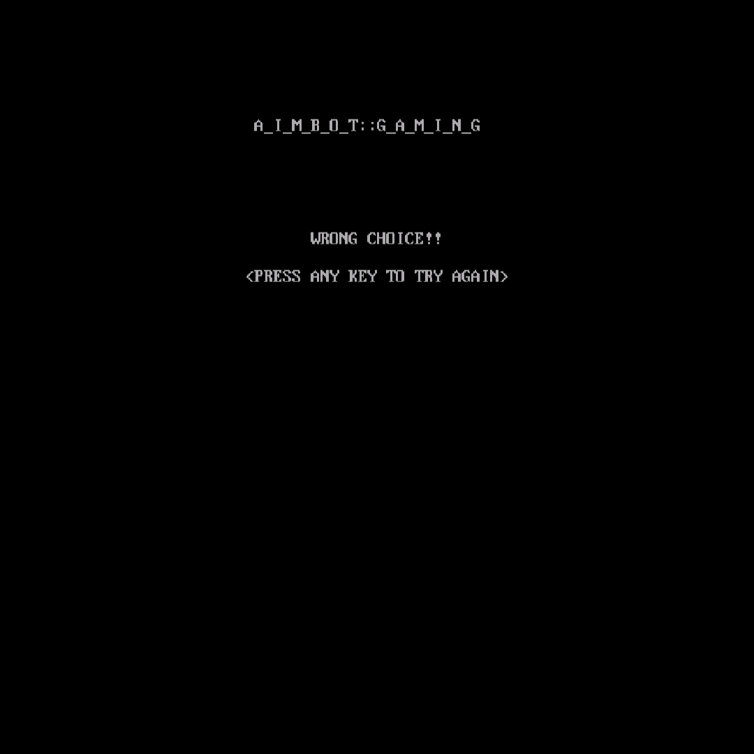

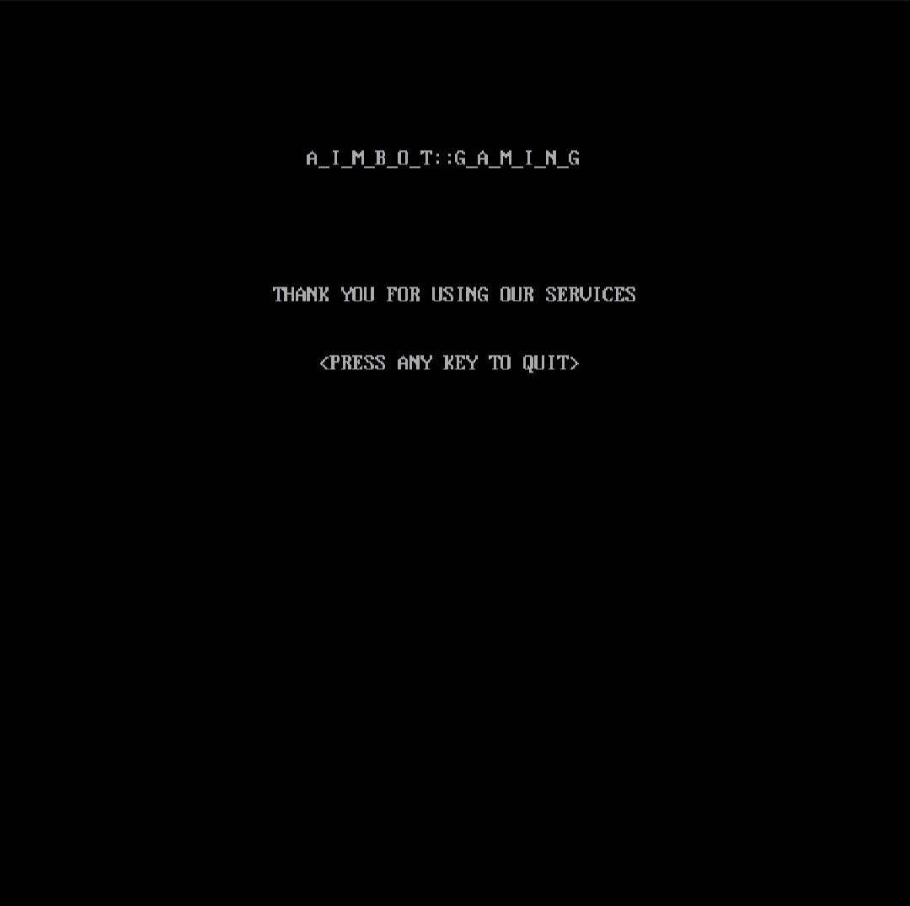

BIBLIOGRAPHY

* Computer Science with C++ : Sumita Arora
* Object Oriented Programming

with C++ : E Balagurusamy